the School counseling program
John Carroll University
The Practicum & Internship Handbook

The School Counseling Program
Department of Counseling
John Carroll University
1 John Carroll Blvd.
University Heights, OH 44118
Last Revised: 9/4/2020

For Questions Contact:
Dr. Andrew Intagliata, School Counseling Coordinator
Phone 216-397-4617
Email: aintagliata@jcu.edu

Amy Zucca, Clinical Coordinator Assistant
Phone: 216-397-1708
Email: azucca@jcu.edu

Table of Contents
Introduction – How to Use this Handbook 6
Practicum (CG 591) Course Requirements 8
Requirements for the Practicum Experience 8
Portfolio 8
Additional Details Regarding Requirements for Practicum 8
Practicum Grading 9
Concerns and Dismissal 9
Things to Do Before Practicum (CG 591) 10
School Counseling Program Practicum Registration Intent Form 10
Determine Your Practicum Site 10
Make Contact with Potential Practicum Site(s) 11
Set Up an Interview 11
Register for CG 591 Practicum in School Counseling 11
BCI/FBI Background Check 11
School Counseling Program Practicum/Internship Student and Site Information Form 11
Student Liability Insurance 11
Participatory Agreement 12
Assignment of Supervisor Form 12
Supervisors Qualifications Form 12
Assumption of Risk Waiver 12
Review/Checklist for Starting Practicum (CG 591) 13
Things to Do During Practicum (CG 591) 13
Things to Do by the End of Practicum (CG 591) 13
Internship (CG 598A and CG 598B) Course Requirements 14
Requirements for Internship Experience 14
Portfolio 14
Additional Details Regarding Requirements for the Internship Experience 14
Suggested Direct Service Categories for School Counseling Internship 15
Internship Grading 16
Concerns and Dismissal 16
Things to Do Before Internship 1 & 2 (CG 598A&B) 17
Determine Your Internship Site 17
Register for CG 598A or B Internship in School Counseling 17
School Counseling Program Practicum/Internship Student and Site Information Form 17
Student Liability Insurance 17
BCI/FBI Background Check 18
Participatory Agreement, Assignment of Supervisor Form, and Site Supervisor Qualifications Form 18
Assumption of Risk, Release, and Waiver of Liability for Student Practicum/Internship 18
Review/Checklist for Starting Internship (CG 598A or B) 18
Things to Do During Internship 1& 2 (CG 598A&B) 18
Apply for Graduation 19
Comprehensive Exam 19
Things to Do by the End of Internship 1 (CG 598A) 19
Things to Do by the End of Internship 2 (CG 598B) 19
Professional School Counselor Licensure 20
General Licensure FAQs 21
BCI/FBI Background Check 22
Background Check FAQs 22
Appendix A: Forms to Complete Before Practicum (CG 591) 23
School Counseling Program Practicum Registration Intent Form 24
Participatory Agreement 25
Assignment of Supervisor Form 30
Site Supervisor Qualifications Form 31
School Counseling Program Practicum/Internship Student and Site Information Form 32
Electronic Portfolio Outline 33
Appendix B: Forms to Complete During Practicum (CG 591) 34
Practicum/Internship Log (electronic) 35
Practicum/Internship Log (hard copy) 36
School Counseling Practicum/Internship Plan of Action 37
Session Recording Form: Student 38
Session Recording Form: Parent/Guardian 39
Counselor Self-Efficacy Scale 40
Session Review Form 42
Appendix C: Forms to Complete by the End of Practicum (CG 591) 45
Practicum Supervisor Evaluation 46
Professional Performance Fitness Evaluation 48
Counseling Practicum/Internship Assessment of Clinical/School Experience 51
Counselor Competencies Scale – Revised (CCS-R) 54
Appendix D: Forms to Complete Before Internship 1 & 2 (CG 598A & B) 62
School Counseling Program Practicum/Internship Student and Site Information Form 63
Participatory Agreement 64
Assignment of Supervisor Form 69
Site Supervisor Qualifications Form 70
Appendix E: Forms to Complete During Internship 1 & 2 (CG 598A & B) 71
Practicum/Internship Log (electronic) 72
Practicum/Internship Log (hard copy) 73
School Counseling Practicum/Internship Plan of Action 74
Weekly Intern Activity Report & Log 75
Session Recording Form: Student 76
Session Recording Form: Parent/Guardian 77
Session Review Form 78
Client Satisfaction Survey 81
Appendix G: Forms to Complete by the End of Internship 2 (CG 598B) 82
Program Evaluation Form 83
Professional Performance Fitness Evaluation 84
Counseling Practicum/Internship Assessment of Clinical/School Experience 87

Dear Student:
Welcome to the clinical experience component of the school counselor program. This handbook describes the final step in your formal training within your Master's program and will provide the information you need to plan for and complete the practicum/internship experience.

An important facet of your program, the practicum and internship courses provide the opportunity to test your academic coursework as you put into practice the counseling theories, techniques, and procedures you have learned. During practicum/internship, you will assume the role of the professional school counselor-in-training and provide services to students, staff and parents within a school under appropriate supervision.

This handbook will give you general information about practicum and internship and a step-by-step process for you to identify and plan for your practicum and internship experiences. It is important that your site suits your learning requirements and provides you an opportunity to meet your knowledge and skills objectives. Once a potential site has been located, the School Counseling Practicum/Internship Coordinator will document the appropriateness of the setting and supervision.

Begin the process early. If you have questions at any point in this process, please contact your advisor or the School Counseling Practicum/Internship Coordinator (Dr. Andrew Intagliata, aintagliata@jcu.edu).

Sincerely,

Faculty Members of John Carroll University’s
Department of Counseling

Introduction – How to Use this Handbook
This handbook is designed to provide comprehensive information that will assist you in completing the Practicum and Internship experience required for the completion of your degree program. You are encouraged to become thoroughly familiar with its contents, much of which are designed to meet state and national licensure requirements.

Definitions
In order to promote a clear understanding of the meanings intended in this handbook, a number of specific terms are defined.
School Counseling Practicum Student— A student in training to be a school counselor who is enrolled in CG 591 School Counseling Practicum. The practicum course is an entry-level experience, less intensive than the internship course.

School Counseling Intern— A student in training to be a school counselor who is enrolled in a specific internship course, CG 598A/B School Counseling Internship. By previously completing the academic and experiential requirements of the practicum course, this student has satisfied the prerequisites necessary to enroll in the internship component of the program.

School Counselor Trainee— An individual who is seeking licensure as a professional School Counselor and who is currently enrolled in either a practicum or internship within a counselor education program approved by the Ohio Department of Education. By definition, this term includes both practicum students and interns. This term should be used by both practicum students and interns to designate properly and legally a training status within the profession.

Practicum/Internship Site— The location where the practicum/internship experience occurs. This site must meet John Carroll University training program standards for the practicum/internship experiences. A significant portion of the practicum/internship experience must involve direct client contact in this regard. This site must also provide the practicum student or intern with opportunities to perform all activities that a regular employed staff member is expected to perform. These activities must be within the scope of counselor training as delineated by the CACREP Standards for School Counselors mandated by the Ohio Department of Education. All sites must be approved by JCU. The practicum and internship experiences are typically completed at the same location.

School Counseling Coordinator—This individual is responsible for discussing specific requirements for the practicum/internship experience with the practicum student or intern.

Dr. Andrew Intagliata currently occupies this position within the School Counseling Program and may be reached directly at (216) 397-4617. His office is located in AD 307.

Clinical Coordinator Assistant—This individual collects paperwork related to the practicum/internship experience prior to semester-specific deadlines, maintaining an updated file for each practicum/internship student.

Amy Zucca currently occupies this position within the Counseling Program and may be reached directly at 216-397-1708 or at azucca@jcu.edu. Her office is located in AD309.
Practicum Instructor or Internship Instructor— This individual instructs a weekly or bi-weekly course during which individual student progress is monitored and individual case studies are presented. In this way, group supervision of students is provided. In some instances, instructors may provide student supervision on an individual basis. The instructor maintains communication with on-site supervisors as indicated, making one on-site visit each semester. Any dialogue regarding significant problems occurring on-site will be initiated with the assistance of this instructor. At the conclusion of the practicum/internship experience, the instructor secures confidential site evaluations from students, delivers these site evaluations to the School Counselor Practicum/Internship Coordinator, and assigns credit for the practicum or internship course.

John Carroll University Practicum Supervisor— This individual meets with practicum students on a weekly basis, providing personalized supervision and a weekly review of specific on-site cases encountered by the practicum student. Utilized during the practicum experience only, this supervisor is typically a John Carroll University faculty member or a part time faculty member working under the supervision of John Carroll University faculty. During weekly meetings with the John Carroll University Practicum Supervisor, individual cases are reviewed and counselor trainee progress and performance is critiqued and evaluated. At the conclusion of the semester, this supervisor provides the practicum instructor with a completed Professional Performance Fitness Evaluation, which summarizes the student’s progress over the course of the semester. Concurrently, this supervisor is also evaluated by each student, through use of the John Carroll University Practicum Supervisor Evaluation Form.

Practicum/Internship Site Supervisor— This individual is a school counselor with at least two years of experience and a professional staff member at the practicum or internship site who is directly responsible for providing systematic, intensive supervision of the student's professional training activities and performance. This supervisor must make appropriate provisions for the student’s orientation to the practicum or internship site (procedures for assigning clients, emergency procedures, site-specific limits to confidentiality, etc.), providing whatever on-site student working space is feasible. Student goals are developed with the assistance of this supervisor, who maintains responsibility for on-site continuity throughout the practicum/internship experience. This supervisor assists in the evaluation of student performance relative to the stated objectives of the practicum/internship experience, by completing the Professional Performance Fitness Evaluation at the conclusion of practicum and the Counselor Competencies Scale – Revised (CCS-R) at the conclusion of the CG 598A and CG 598B. At this same time, this supervisor completes John Carroll University Counseling Program Evaluation form.

Practicum (CG 591) Course Requirements
The course, Practicum in School Counseling (CG 591), is the bridge between the coursework in clinical foundations and the more extensive implementation of the role of the professional school counselor during internship. It is expected that students will have taken the core coursework requirements in order to be considered for Practicum.

It is required that students complete the following prerequisite courses before starting Practicum:
- Orientation to Counseling (CG 500)
- Foundations of School Counseling (CG 500)
- Counseling Theories (CG 561)
- Counseling Techniques (CG 562)
- *Group Dynamics, Processing, and Counseling (CG 535)

*students may take CG 535 concurrently with Practicum

Students are considered eligible for practicum when these first four courses (CG 500, 501, 561, and 562) have been completed. Please discuss any questions with the Practicum Coordinator.

Practicum in School Counseling (CG 591) is a prerequisite for School Counseling Internship A (CG 598A), and Diversity Issues in Counseling (CG 563) is a co-requisite for CG 598A. Additionally, CG 591, CG 598A and CG 598B are only offered during Fall and Spring semesters, so please keep these things in mind as you create your academic planning guide.

Requirements for the Practicum Experience
The practicum experience requires a total of 100 clock hours, including a minimum of 40 hours of direct counseling services with clients (which must include group work), one hour per week of supervision with a JCU Practicum Site Supervisor (i.e., your site supervisor), and the practicum seminar for 1 ½ hours. All hours in relation to CG 591 coursework should be recorded on the Practicum/Internship Log Sheet. This completed form will be presented to the Practicum Instructor bi-weekly during the semester. CG 591 meets for 1 ½ hours weekly for group supervision one hour of triadic supervision weekly. Students are required to present cases during group supervision. In this way, the student will gain expertise in appropriate case consultation with fellow practitioners.

Portfolio
Students will maintain an electronic portfolio for the entire practicum/internship experience, which can be done electronically and shared with your instructor via the Google Drive associated with your JCU account. An outline of items to be kept in the portfolio can be found here. Students are responsible for keeping copies of ALL paperwork for ALL three semesters in their portfolios and will be required to turn in/share their portfolio for review at the completion of each course (CG 591, CG 598A, and CG598B). Some of the forms will be turned in to the instructor at that time.

Additional Details Regarding Requirements for Practicum
The minimum of 40 direct counseling service client/student contact hours must include work with at least three different individual students and at least one group.

Each student must meet individually with a John Carroll University Practicum Supervisor (site supervisor) for at least one hour per week. Over the course of the semester, the student will present case material for the Practicum Supervisor. Discussion of these cases should include a focus on student issues and the investigation of particular aspects of counseling. Understanding the student, developing rapport with the student, defining the student’s problem, enhancing counseling skills within the context of the counseling session, and selecting counseling interventions are all relevant examples of potential supervision discussions.

The practicum course incorporates two types of supervision— individual supervision (through the John Carroll University Practicum Supervisor and the Site Supervisor) and group supervision (through weekly class meetings and triadic supervision with the Practicum Instructor). The student will complete a formal evaluation of their John Carroll Practicum Supervisor at the conclusion of the practicum course.

The practicum experience requires the development of specific objectives by the student and the demonstration of behavior in accordance with the ethical and professional standards delineated in the American School Counselor Association’s Ethical Standards for School Counselors. These standards can be found on the ASCA website.

Additional assignments—including student self-evaluations, John Carroll University Practicum Supervisor evaluations, and site supervisor evaluations of student progress—will be addressed at the outset of the practicum course and detailed in the course syllabus. Over the course of the semester, students may be required to complete other duties such as listening to case material of counseling sessions, researching particular student populations in order to prepare for counseling sessions, or completing related paperwork.

At the completion of the course, Professional Performance Fitness Evaluation to be completed by:
- The JCU Practicum student
- The JCU Practicum Supervisor/site supervisor
- The JCU Practicum Instructor

Practicum Grading
Credit (CR) is assigned by the Practicum Instructor in a Pass or Fail format based on points accumulated throughout the semester on different assignments. If the Practicum Instructor or the Site Supervisor has concerns regarding a student's progress, the Practicum Instructor will meet with the student and the Site Supervisor during the course of the semester to determine an appropriate course of action.

Concerns and Dismissal
Program faculty maintain the right and responsibility to review at any time any circumstance or behaviors by a student that could affect the student’s status in the practicum/internship experience. Faculty also maintain the right to, at any time, review competencies for individual professional practice that may impact whether a student should continue in the school practicum/internship experience. Faculty have the right and responsibly to review students whose demeanor or behaviors might threaten the welfare or well-being of a student. JCU students can be given a failing grade or asked to drop the course if there is evidence of unethical, unprofessional, or impaired behaviors including but not limited to the following:
- violation of professional standards or ethical codes;
- inability or unwillingness to acquire or manifest professional skills at an acceptable level of competency;
- behaviors that can reasonably be predictive of poor future professional functioning, such as extensive lateness, unethical record-keeping, or poor compliance with supervisory requirements;
- interpersonal behaviors and interpersonal functioning that impairs one's professional functioning;
- inability to exercise sound clinical judgment, poor interpersonal skills, and pervasive interpersonal problems;
- Academic misconduct or dishonesty;
- Criminal conviction/felony;
- Failure to comply with university or department timetables and requirements;
- Cognitive, affective, and/or behavior impairments that obstruct the training process and/or threaten the welfare of others;
- Substance abuse;
- Substandard evaluation on the CCS-R.

Practicum/Internship sites also retain the right to dismiss students from the site for any reason. If a student is dismissed from the site or if a student leaves the site voluntarily, the hours collected at that site may not be used towards completion of hours for practicum/internship. For any concerns with a student during their school practicum/internship experience, a concern conference with the Chair of the Counseling Department will be scheduled and students may be asked to do remedial work or dismissed from the program. Students will not receive credit for the course until practicum/internship hours are completed.

Things to Do Before Practicum (CG 591)
In order to apply for the Practicum course, students will have various forms to complete.

School Counseling Program Practicum Registration Intent Form
The first step of the practicum/internship process is electronically submitting the School Counseling Program Practicum Registration Intent Form. It will assist in clarifying your needs and goals at each phase of your clinical experience. A confirmation email of your submission will be sent to you. Keep a copy of this email in your portfolio.

This form MUST be submitted no later than MARCH 1 for a practicum starting during the Fall semester and no later than OCTOBER 1 for a practicum start during the Spring semester. Students applying later than these dates will not be permitted to enroll in CG 591. You do not need to have a site by this time, but you must fill out this form saying you intend to start your practicum in that upcoming semester. Deadlines for finding a site will be covered later in this Handbook.

Determine Your Practicum Site
Students who need assistance in finding a practicum site may consult with the School Counseling Practicum/Internship Coordinator who will assist students in developing a list of potential sites. You may also consult the School Counseling Practicum & Internship Directory.

Make Contact with Potential Practicum Site(s)
If you are planning to do your field experience at the school where you are teaching, schedule an interview with the school principal and senior school counselor. If you are not currently employed in a school, once you have identified several potential internship sites, it is recommended that you begin making telephone calls/sending emails and scheduling appointments early in the process. When you call each school, ask to speak directly with the senior ranking school counselor and inquire about the specific services provided by each school that a counseling intern would be able to offer. When possible, request an on-site interview at potential schools of interest. Take copies of this manual and your resume with you. It is recommended that you keep a record of the persons you contact and list their positions at the school.

Set Up an Interview
For helpful tips regarding this area, consult the School Counseling Practicum & Internship Directory.

Register for CG 591 Practicum in School Counseling
Register for CG 591 using BannerWeb.

BCI/FBI Background Check
To obtain BCI/FBI fingerprints and background checks you can call JCU PD and set up an appointment at 216-397-1615. JCUPD is located on the Ground Floor of the D.J. Lombardo Student Center, Room 14. You can also check this website to find other fingerprinting locations: http://www.ohioattorneygeneral.gov/Business/Services-for-Business/WebCheck/Webcheck-Community-Listing.

School Counseling Program Practicum/Internship Student and Site Information Form
Notification of finding a site must be submitted by MAY 1 for a practicum starting during Fall semester and no later than DECEMBER 1 for a practicum starting during Spring semester. These deadlines are non-negotiable. Use the online School Counseling Program Practicum/Internship Student and Site Information Form to submit this information. A confirmation email of your submission will be sent to you. Keep a copy of this email in your portfolio. Failure to submit this by the deadlines indicated above may result in a student being unable to enter the course.

Student Liability Insurance
Practicum and internship students are required to possess liability insurance required for coverage during the entire practicum/internship experience. Students should obtain a personally held policy, even if coverage is provided by their employer.

The American Counseling Association (ACA) offers a free student rate for liability insurance. Students are advised to choose the $1,000,000—$3,000,000 coverage. Students must be members of ACA and in a Master’s Level counseling program. There is a student rate of $105 to join ACA.

The American School Counselor Association (ASCA) also offers students liability insurance as part of a student membership to ASCA in the form of $1,000,000 - $1,000,000 coverage. There is a student rate of $69 to join ASCA.
The ACA Insurance Trust, Inc. (ACAIT) has partnered with Healthcare Providers Service Organization (HPSO) to provide a comprehensive professional liability program for students. Students interested in obtaining liability insurance for $37 through this program and not join ACA, should call ACAIT for an application (1-800-347-6647 extension 284) or apply online by visiting the website: www.hpso.com. This is a less expensive option, however joining one’s professional organization is both important and allows students other membership benefits as well.

If students do not want to apply by credit card, send address or fax number to have an application sent via mail to:
ACA Insurance Trust, Inc.
5999 Stevenson Avenue
Alexandria, VA 22304
Phone (800) 347-6647 ext. 284
Fax (703) 823-5267
Email: pnelson.acait@counseling.org

Students can also purchase liability insurance on their own through a private policy. Once liability insurance is obtained, a copy of the student policy should be provided to their practicum instructor and as well as maintained by the student for inclusion in the practicum/internship portfolio. Keep in mind that ACA insurance coverage is for one year only and others may be as well, so apply closer to the start of your practicum or plan to renew during your internship.

Participatory Agreement
This Participatory Agreement must be signed by the student, site supervisor, school principal, and John Carroll University representative and turned in no later than the first day of practicum/internship class.

Assignment of Supervisor Form
The Assignment of Supervisor Form must be signed by the site supervisor and turned in no later than the first day of practicum/internship class.

Supervisors Qualifications Form
The site supervisor must complete the Site Supervisor Qualifications Form and turned in no later than the first day of practicum/internship class.

Assumption of Risk Waiver
Starting with the Fall 2020 semester, counseling students are required to sign an Assumption of Risk, Release, and Waiver of Liability for Student Practicum/Internship in order to participate in practicum and internship. At your school placement sites, it’s important that you follow the schools’ health and safety guidelines, especially as they relate to COVID-19 preventative measures. You should also familiarize yourself with the guidelines provided by the Center for Disease Control.
This form will be emailed to you and you will fill it out electronically. THE DEADLINE TO SUBMIT THE FORM IS ONE WEEK BEFORE CLASSES START.
If you do not feel safe at your site, then you may terminate your experience there. We will work with you to help you find a different clinical placement site.
If you are exposed to coronavirus or someone who has tested positive, then you should contact the University Health Center by phone or email to advise them of this. You should also report this to the school counseling practicum/internship coordinator, Dr. Intagliata, and you will be required to self-quarantine for 14 days and not come onto campus. If you are symptomatic, then you will need to self-isolate for a period of time identified by your healthcare provider, the board of health, and/or the University Health Center.

Review/Checklist for Starting Practicum (CG 591)
- School Counseling Program Practicum Registration Intent Form
- Use the School Counseling Practicum & Internship School Directory to help you find a site, set up interview, secure a site.
- School Counseling Program Practicum/Internship Student and Site Information Form
- Proof of personally held liability insurance (ACA, ASCA, HPSO)
- Register for CG 591
- Get background check done
- Participatory Agreement
- Assignment of Supervisor Form
- Site Supervisor Qualifications Form
- Assumption of Risk, Release, and Waiver of Liability for Student Practicum/Internship

Keep copies of all these forms/confirmations in your electronic portfolio. These will be reviewed in the first day of class.

Things to Do During Practicum (CG 591)
The Appendix of this Handbook contains some of the forms that you will need to complete during your practicum. However, these forms and others will be explained more fully in your Practicum Course Syllabus. Please make additional copies as needed. If you have any questions about a form please consult your instructor or the school counseling coordinator, Dr. Andrew Intagliata (aintagliata@jcu.edu).

Things to Do by the End of Practicum (CG 591)
Forms can be found in the Appendices. If you have any questions about a form please consult your instructor or the School Counseling Coordinator, Dr. Andrew Intagliata (aintagliata@jcu.edu).

It is your responsibility to fill the forms out and give them to the appropriate person(s).
Please read these forms carefully. If necessary, make multiple copies of these forms.
Please print legibly or type responses.
- Practicum Supervisor Evaluation
- Professional Performance Fitness Evaluation. To be completed by:
- JCU practicum student
- JCU practicum site supervisor
- JCU practicum instructor
- Counselor Competencies Scale - Revised (CCS-R): This instrument provides evidence of your growth and development in counseling skills, behaviors, and dispositions. Please note that the CCS-R was piloted fall 2015 and spring 2016. The CCS-R will be emailed to your licensed site representative to complete online and a summary report of your responses will be emailed to you at the end of the semester. Keep a copy in your portfolio.
- Counseling Practicum/Internship Assessment of Clinical/School Experience

Internship (CG 598A and CG 598B) Course Requirements
The internship is designed to be an intensive hands-on experience conducted in a setting similar to one in which the student will eventually find employment. The internship experience should incorporate activities specific to the practice of professional school counseling, with consistent and extensive supervision.

CG 598A/B Internship in School Counseling can be taken only after a student has successfully completed CG 591 Practicum in School Counseling and its related prerequisites. Students must also take CG 563 Diversity Issues in Counseling either before or during CG 598A.

Requirements for Internship Experience
The internship experience program requires a total of 600 clock hours on-site, including a minimum of 240 hours of direct service with students (individually and in group format) and a minimum of one hour of direct supervision with the Internship Site Supervisor for every 20 hours on-site. All hours in relation to CG 598 coursework should be recorded on the Practicum/Internship Log. CG 598A/B class meets for 3 hours bi-weekly or 1 ½ hours weekly. Students are required to present case studies (possibly including portions of audio or video recorded material) to the class. In this way, the student will gain further expertise in participating in appropriate case consultation with fellow practitioners. The internship experience provides opportunities for students to gain supervised experience in the use of a variety of professional resources that include print and non-print media, professional literature, research findings, and appropriate referral sources and providers.

Portfolio
Students will maintain an electronic portfolio for the entire practicum/internship experience, which can be done electronically and shared with your instructor via the Google Drive associated with your JCU account. An outline of items to be kept in the portfolio can be found here. Students are responsible for keeping copies of ALL paperwork for ALL three semesters in their portfolios and will be required to turn in/share their portfolio for review at the completion of each course (CG 591, CG 598A, and CG598B). Some of the forms will be turned in to the instructor at that time.

Additional Details Regarding Requirements for the Internship Experience
The minimum of 240 direct counseling service student contact hours must include work with students in both individual and group formats. Additionally, it is strongly encouraged that students gain experiences presenting in classrooms or leading/co-leading classroom guidance lessons. For suggested direct service categories in the school setting see here .

The internship course incorporates two types of supervision—individual supervision (through the Internship Site Supervisor) and group supervision (through weekly or bi-weekly class meetings with the Internship Instructor). The Site Supervisor will complete a formal evaluation of the intern following the completion of the required 600 on-site hours. This evaluation is designed to include an opportunity for the intern and Site Supervisor to consult formally regarding the student's performance during the internship. This evaluation will eventually be forwarded to the Internship Instructor for inclusion in an overall evaluation of the student’s work during the semester.

The internship experience requires the development of specific objectives by the student and the demonstration of behavior in accordance with the ethical and professional standards delineated in the American School Counseling Association’s Ethical Standards for School Counselors. These standards can be found on the ASCA website.

Additional assignments will be addressed at the outset of the internship course and detailed in the course syllabus. By design, CG 598 is focused on the on-site component of the experience, as direct supervision is experienced on site and students increase their amount of hours on-site. CG 598 A and B are taken for a total of 6 credit hours and broken up over two semesters. CG598A and B cannot be taken during the same semester.

Suggested Direct Service Categories for School Counseling Internship
I. Individual Counseling
One-to-one counseling for any personal, social, academic, career, or developmental concern. The intern may see students on a regular basis if that is possible and required by their site. Some schools may not do as much of this type of counseling while others place greater emphasis in this area. Quality time may only be a few minutes in the hall before class, during lunch, or may take form of a regular appointment in the Counseling Office. Please try to log as much one-one-one counseling time as possible.

II. Group Counseling
Small groups of children exploring a common theme are popular in most schools. Groups in the elementary setting on anger management, divorce, socialization skills, conflict resolution, ADHD, and grief/loss are just some of the themes interns have worked with in the past. At the middle school level, such themes as making and keeping friends, self-esteem, respecting rules and adults, alcohol and drug abuse prevention, and test anxiety are popular. High school interns have developed successful groups on body image, healthy living, self-esteem, sexuality issues, stress management, and preparing for college. Group counseling should address a particular theme usually over several sessions with anywhere from 4-12 students, should be psycho-educational, and should provide opportunity for interaction by all members rather than groups where teaching takes place in a classroom setting. (See Below)

III. Group Guidance/Classroom Guidance Lessons
Larger class-sized groups where the intern has an opportunity to present a topic to the group and where some opportunity is provided for questions and comments, from at least a portion of those present, may be counted for some of the intern’s group time. It is expected, however, that such groups will make up a considerably shorter portion of group time than the above categories of individual and group counseling. These groups are important and offer an excellent and practical way of addressing real school counseling issues to larger groups. Drug abuse prevention, proficiency test preparation, test score interpretation, and career exploration are some of the themes that can be addressed in this fashion by school counseling interns.

IV. Participation in IEPs or 504 Meetings
Interns may count time served on such teams as direct service to children, as well as any time spent observing and gathering information for the purpose of these meetings. Those interns whose professional background in Special Education and whose duties require their regular participation on such teams may count some of this time for internship, but other experiences should dominate the intern’s log in areas where little or no time has been spent before.

V. Testing and Appraisal
Interns may administer tests if they are judged qualified to do so by a supervisor. They may count this time as direct service if the testing is also followed by interpretation of student’s scores in some way to them. In some locations, PSAT pre-testing sessions have been held with students to help them with test taking anxiety and test taking strategies. Some interpretation of what the returned scores mean to the individual student may be offered if this time is to count as counseling service.

VI. Parent/Guardian and Teacher Consultation
Time spent working with parent/guardians is considered direct service time, as well as working with teachers for the benefit of improving the school success of students.

Internship Grading
Credit (CR) is assigned by the Internship Instructor as a Pass or Fail grade based on points accumulated on assignments throughout the semester. If the Internship Instructor or the Site Supervisor has concerns regarding a student's progress, the Internship Instructor will meet with the student and the Site Supervisor during the course of the semester to determine an appropriate course of action. Students who have not completed 600 on-site hours and/or 240 direct hours by the end of CG598B will receive an "in progress" grade and will be required to register for an additional semester of internship until they complete the requirements for the internship course.

Concerns and Dismissal
Program faculty maintain the right and responsibility to review at any time any circumstance or behaviors by a student that could affect the student’s status in the practicum/internship experience. Faculty also maintain the right to, at any time, review competencies for individual professional practice that may impact whether a student should continue in the school practicum/internship experience. Faculty have the right and responsibly to review students whose demeanor or behaviors might threaten the welfare or well-being of a student. JCU students can be given a failing grade or asked to drop the course if there is evidence of unethical, unprofessional, or impaired behaviors including but not limited to the following:
- violation of professional standards or ethical codes;
- inability or unwillingness to acquire or manifest professional skills at an acceptable level of competency;
- behaviors that can reasonably be predictive of poor future professional functioning, such as extensive lateness, unethical record-keeping, or poor compliance with supervisory requirements;
- interpersonal behaviors and interpersonal functioning that impairs one's professional functioning;
- inability to exercise sound clinical judgment, poor interpersonal skills, and pervasive interpersonal problems;
- Academic misconduct or dishonesty;
- Criminal conviction/felony;
- Failure to comply with university or department timetables and requirements;
- Cognitive, affective, and/or behavior impairments that obstruct the training process and/or threaten the welfare of others;
- Substance abuse;
- Substandard evaluation on the CCS-R.

Practicum/Internship sites also retain the right to dismiss students from the site for any reason. If a student is dismissed from the site or if a student leaves the site voluntarily, the hours collected at that site may not be used towards completion of hours for practicum/internship. For any concerns with a student during their school practicum/internship experience, a concern conference with the Chair of the Counseling Department will be scheduled and students may be asked to do remedial work or dismissed from the program. Students will not receive credit for the course until practicum/internship hours are completed.

Things to Do Before Internship 1 & 2 (CG 598A&B)

Determine Your Internship Site
Student may choose to stay at their practicum site to continue with internship, go to a different site for internship, or stay at the same practicum site and add another site in order to complete internship at multiple schools. Students who need assistance in finding an internship site may consult with the School Counseling Practicum/Internship Coordinator (Dr. Andrew Intagliata, aintagliata@jcu.edu) who will assist students in developing a list of potential sites. You may also consult the School Counseling Practicum & Internship Directory.

Register for CG 598A or B Internship in School Counseling
Register for CG 598A or B using BannerWeb.

School Counseling Program Practicum/Internship Student and Site Information Form
Notification of finding a site must be submitted by MAY 1 for an internship starting during Fall semester and no later than DECEMBER 1 for an internship starting during Spring semester. These deadlines are non-negotiable. Use the online School Counseling Program Practicum/Internship Student and Site Information Form to submit this information. A confirmation email of your submission will be sent to you. Keep a copy of this email in your portfolio. Failure to submit this by the deadlines indicated above may result in a student being unable to enter the course. You need to submit this form even if you are staying at the same site where you were for practicum!

Student Liability Insurance
Make sure your student liability insurance is up to date. You may need to renew this during internship, as many liability insurance agreements are good for one year.

BCI/FBI Background Check
You may need to complete another background check depending on how old your previous one is and whether your site requires a new background check. To obtain BCI/FBI fingerprints and background checks you can call JCU PD and set up an appointment at 216-397-1615. JCUPD is located on the Ground Floor of the D.J. Lombardo Student Center, Room 14. You can also check this website to find other fingerprinting locations: http://www.ohioattorneygeneral.gov/Business/Services-for-Business/WebCheck/Webcheck-Community-Listing.

Participatory Agreement, Assignment of Supervisor Form, and Site Supervisor Qualifications Form
Make sure to fill these out before Internship A. You will need to submit the Participatory Agreement and the Assignment of Supervisor Form even if you are staying at the same site as practicum. You do not need to fill out a Site Supervisor Qualifications Form if you are staying at the same site as practicum and had previously turned in this in for CG 591.

Assumption of Risk, Release, and Waiver of Liability for Student Practicum/Internship
This waiver needs to be filled out and submitted prior to Internship A and Internship B.

Review/Checklist for Starting Internship (CG 598A or B)
- Register for CG 598A or B.
- School Counseling Program Practicum/Internship Student and Site Information Form - you need to submit this form even if you are staying at the same site
- Proof of personally held liability insurance – click here for more information or go here (ACA, ASCA, HPSO) for student rates
- Background check (if previous one is expired or site requires it)
- Participatory Agreement
- Assignment of Supervisor Form
- Site Supervisor Qualifications Form
- Assumption of Risk, Release, and Waiver of Liability for Student Practicum/Internship
- Apply for Graduation during CG 598A
- Register to take the Comprehensive Exam

Keep copies of all these forms/confirmations in your electronic portfolio. These will be reviewed in the first day of class.

Things to Do During Internship 1& 2 (CG 598A&B)
The Appendix of this Handbook contains some of the forms you will need to complete your internship. However, these forms and others will be explained more fully in your Internship Course Syllabus. Please make additional copies as needed. It is your responsibility to fill the forms out and give them to the appropriate person(s). Please read these forms carefully, and please print legibly or type responses. If you have any questions about a form please consult your instructor or the school counseling coordinator, Dr. Andrew Intagliata (aintagliata@jcu.edu).

Apply for Graduation
Apply for graduation through the Graduate Studies Office. For spring graduation, the deadline is the fourth Monday of November. For summer graduation, the deadline is February 15. For degrees awarded in winter, the deadline is the second Monday of July. Students usually apply for graduation during CG 598A, i.e. one and a half to two semesters prior to the intended graduation date.

**Please note that students must pass the comprehensive exam in order to graduate.

Comprehensive Exam
The final examination requirement for the Master’s Degree in School Counseling is satisfied through successful completion of the Master’s Comprehensive Examination, also known as the Counselor Preparation Comprehensive Exam (CPCE). Students should take the exam before their last semester in the program. That way if a student does not receive a passing grade, they have an additional semester before the anticipated graduation date to retake the test.

Important to note: Students need to take and pass the test no later March 31 if they wish to graduate at the end of spring semester, no later July 31 if they wish to graduate at the end of summer semester, and no later than November 30 if they wish to graduate at the end of fall semester. The exam must be passed before a student can graduate from the program. More information on the CPCE (e.g., content, description of exam, eligibility requirements, preparing for the exam, registration information, accommodations, and exam scoring) can be found here.

Things to Do by the End of Internship 1 (CG 598A)
There are forms that you will need to complete by the end of internship A. Please make additional copies as needed. These forms will be explained more fully in your Internship Course Syllabus. It is your responsibility to fill the forms out and give them to the appropriate person(s). Please read these forms carefully. If necessary, make multiple copies of these forms. Please print legibly or type responses.
- Counselor Competencies Scale - Revised (CCS-R): This instrument provides evidence of your growth and development in counseling skills, behaviors, and dispositions. Please note that the CCS-R was piloted fall 2015 and spring 2016. The CCS-R will be emailed to your licensed site representative to complete online and a summary report of your responses will be emailed to you at the end of the semester. Keep a copy a copy in your portfolio.

Things to Do by the End of Internship 2 (CG 598B)

There are forms that you will need to complete by the end of internship B. Please make additional copies as needed. These forms will be explained more fully in your Internship Course Syllabus. It is your responsibility to fill the forms out and give them to the appropriate person(s). Please read these forms carefully. If necessary, make multiple copies of these forms. Please print legibly or type responses.
- Program Evaluation Form: Student completes one, supervisor completes one
- Counselor Competencies Scale - Revised (CCS-R): This instrument provides evidence of your growth and development in counseling skills, behaviors, and dispositions. Please note that the CCS-R was piloted fall 2015 and spring 2016. The CCS-R will be emailed to your licensed site representative to complete online and a summary report of your responses will be emailed to you at the end of the semester. Keep a copy a copy in your portfolio.
- Counseling Practicum/Internship Assessment of Clinical/School Experience. Return this form to the Clinical Coordinator Assistant, Amy Zucca, in AD 309 (or via email, azucca@jcu.edu).

If a student has not completed the necessary hours by the end of Internship II (CG 598B) at the site, they may get a PR in the course and would be required to register for another semester of internship in order to complete their hours.

Professional School Counselor Licensure

To apply for a professional school counselor license, submit an online application found at the Ohio Department of Education. You will be required to create an OH|ID account for your online license application. You will need a Professional Pupil Services license specializing in school counseling in order to practice in the state of Ohio. The initial license is a 5-year professional license. ODE no longer accepts paper applications.

Requirements for Obtaining a School Counselor License:
1. Completion of an approved school counselor training program of preparation in Ohio;
2. Passing score on the Ohio Assessment for Educators (OAE) School Counselor Exam (040);
3. Completion of a BCI/FBI background check

Ohio Assessments for Educators

All school counselors in Ohio need to pass the Ohio Assessment for Educators (OAE) School Counselor Exam (040) in order to apply for their Professional Pupil Services License. It is recommended to take this exam towards the end of the school counseling program. It is also recommended that it be taken in a different semester than the John Carroll University comprehensive exam. You are not required to pass this licensure exam before you graduate, but you will need to pass this exam in order to get your school counseling license in the state of Ohio.

The OAE is a 150-question multiple choice computer-based test. The test must be completed in three hours and a score of 220 is needed to pass. The exam can be taken year-round. The cost of one exam is $105 and to take the exam you must agree to all testing rules and policies.

You can visit the following website for more information: http://www.oh.nesinc.com/

• Under the Registration tab you can register for an account and pay for an exam. After you have paid for the exam you can then register for a specific testing date.
• Under the Prepare tab you can find free information on the make of the exam. This website also has information regarding the design and framework for the exam (i.e., what is covered on the test), test preparation materials including practice assessments and study guides (available for a fee), test taking strategies, and sample questions.

General Licensure FAQs

Where can I find information about how to get licensed?
- Go to the Ohio Department of Education (ODE) website (www.education.ohio.gov) or to Ohio School Counselors Association (OSCA) (www.ohioschoolcounselor.org) website for information on how you may get licensed.

What are the requirements for obtaining a school counselor license if I successfully complete a training program in Ohio?
- Passing score on the Ohio Assessment for Educators (OAE) School Counseling Exam (040)
- Completion of a BCI/FBI background check

What testing requirements do I have to meet and where can I take that test?
- You must be towards the end of your school counseling training program or after you have graduated/finished your coursework.

I finished my coursework, passed the CPCE, and passed the OAE licensure exam. What else do I need to do to get my license?
- You will need to apply for a license through the Ohio Department of Education. Once you have your ODE application completed, please send an email to the school counseling program coordinator, Dr. Andrew Intagliata (aintagliata@jcu.edu). He will approve the ODE request confirming your completion of the JCU school counseling program.

Can I obtain a temporary school counseling license?
- Yes, you can. ODE has provisions for individuals to obtain a one-year temporary professional pupil service license for those who are hired to work as a school counselor and have not completed their degree programs or are awaiting decisions on professional licensure. The temporary pupil service license will only be issued at the request of an employing Ohio school or district. There are two ways to do this:
  - A valid Ohio board license to practice as a clinical mental health counselor (as issued by the Ohio Counselor, Social Worker, & Marriage and Family Therapist Board) AND enrollment in an approved school counselor licensure program (a letter from JCU is required to verify enrollment); or
  - A valid, standard Ohio teaching certificate or professional teaching license AND enrollment in an approved school counselor licensure program
    - This option requires a letter from the John Carroll University to verify enrollment and that the student in question demonstrates an understanding of each of the following: professional identity, social and cultural diversity, human growth & development, career development, helping relationships, group work, assessment, research & program evaluation.

I have my Master’s Degree in Clinical Mental Health Counseling. Am I able to apply for a five-year school counseling license instead of just the one-year temporary license?
- Yes, provided you complete the post-master’s track in school counseling. This requires you to take any necessary school counseling courses and complete a school counseling internship.
- You will then be required to take and pass the OAE school counseling licensure exam before this five-year license is issued to you.
Who do I contact if I have questions about my license?
- Office of Educator Licensure (614-466-3593, educator.licensure@education.ohio.gov)

BCI/FBI Background Check

To obtain BCI/FBI fingerprints and background checks you can call JCU PD and set up an appointment at 216-397-1615. JCUPD is located on the Ground Floor of the D.J. Lombardo Student Center, Room 14. You can also check this website to find other fingerprinting locations: http://www.ohioattorneygeneral.gov/Business/Services-for-Business/WebCheck/Webcheck-Community-Listing.

Background Check FAQs

Q&A from the Department of Education Website
- How much should I expect to pay for the background checks?
  - Cost of the fingerprinting varies, depending on the location or agency providing the service.
- Where do I send the results of the background check?
  - Licensed educators and applicants for ODE licenses, certificates, and permits need to have the results sent to the Ohio Department of Education. Please tell the agency you use to send the results to ODE.
- Can I send ODE a paper copy of my background check?
  - No, ODE cannot accept paper copies of background checks. ODE is required to use the background checks sent and reported electronically by BCI.

Where can I get a BCI/FBI background check done?
Click here to learn more about the BCI/FBI background check requirements. It is recommended that you first check with your local school district, then neighboring school districts or your region’s Educational Service Center. If none of these have the ability to electronically complete both background checks, then check with your local law enforcement agencies or use the Ohio Attorney General’s Website to find a convenient location.
ODE requests that both background checks (BCI and FBI) be completed electronically through WebCheck so the fingerprints will be sent immediately to BCI. This allows for a much quicker processing of the prints and results reported to ODE. Please ask the agency you use if they have both Ohio and National WebCheck machines. Everyone in Ohio must use WebCheck unless: the individual lives 75 miles away from the nearest WebCheck facility or the individual has a history of ‘bad quality prints’ that cannot be captured on a WebCheck screen. Licensed educators need to have the results sent to the Ohio Department of Education. Please tell the agency you use to send the results to ODE.

Appendix A: Forms to Complete Before Practicum (CG 591)

School Counseling Program Practicum Registration Intent Form
Students must electronically submit the School Counseling Program Practicum Registration Intent Form. It will assist in clarifying your needs and goals at each phase of your clinical experience. A confirmation email of your submission will be sent to you. Keep a copy of this email in your electronic portfolio.

This form MUST be submitted no later than MARCH 1 for a practicum starting during the Fall semester and no later than OCTOBER 1 for a practicum start during the Spring semester. Students applying later than these dates will not be permitted to enroll in CG 591.

Participatory Agreement
John Carroll University
School Counseling Program
PAGE 1 OF 5
CG 591- Practicum or CG 598A/B – School Counseling Internship

Dear Principal,

The school counseling graduate student, ____________________________________________, is nearing the end of a long, rigorous course of study leading to licensure as a school counselor. While John Carroll University believes it has provided required coursework in theory, ethical and legal guidelines for practice, and basic counseling skills and techniques, practical experience is still the best method of learning to become a good school counselor. The student is asking that you consider making your site available for attaining the required number of contact hours of counseling experience with the children and adolescents in your school.

If our student is already employed at your site in a teaching role, we realize valuable release time for the student to meet their obligations for this experience may be required. Further, we appreciate the time you and your staff set aside for a non-employee student. All prospective practicum and/or internship students will have the required background checks and personal liability insurance plans before beginning at your site. We sincerely appreciate your willingness to make this opportunity available to one of our graduate students. We believe the careful, supervised work of our counselor trainees will be a real asset to your school in terms of service to children and the broader school community.

John Carroll University expects the highest of ethical practice from all of its counselor practicum/internship students and we further recognize your right to terminate from practicum or internship any individual who has, upon joint review, been judged to have violated school policy or has otherwise acted in an unprofessional or unethical manner while representing John Carroll on-site. It shall be further understood that no practicum or internship student will expect additional remuneration, compensation, or special consideration for future employment at your site in exchange for their service as a counselor intern.

I welcome and thank you for your joint participation with John Carroll University in providing this opportunity for our student.

Nathan C. Gehlert, Ph.D.
Chair and Associate Professor,
Department of Counseling
Director, Integrated Behavior Health Specialization (216) 397-4697

Participatory Agreement
John Carroll University
School Counseling Program
PAGE 2 OF 5

Part One:
Internship Practicum
Student Name: _______________________________________________________________
Address: ______________________________________________________________________
Work Phone: _______________________Best Time to Call: ______________________
Home Phone: ______________________ Best Time to Call: ______________________
Are you employed at the practicum/internship site? Yes_____ No_____
If yes, how long have you been employed on-site? _______Years
If yes, what are your current duties; subjects taught; grade level(s)?
_________________________________________________________________________________
_________________________________________________________________________________
Part Two:
Practicum/Internship Site School: __________________________________________
Site School’s Address: ________________________________________________________
__________________________________________________________________________________
Site School’s Phone Number: ________________________________________________
Grade Levels Served: _________________________________________________________
Site School’s Principal: _______________________________________________________
Intern’s Supervisory Counselor: _____________________________________________
Site Supervisor’s Phone Number: ____________________________________________
Site Supervisor’s Email: _______________________________________________________

The John Carroll University school counselor practicum/internship student identified in Part One above, is required to complete ____ semesters of practicum / internship (choose one) to complete requirements for State of Ohio licensure as a school counselor. The practicum/internship student is expected to document _______ total hours of practicum/internship experience, including ______ hours of direct service contact with K-12 students present at the site chosen for practicum/internship. Some examples of direct service contact hours are: individual counseling with children; group counseling with children; service as an I.E.P. or 504 team member; direct consultation to a parent of a child. All practicum and internship students are required to be supervised by a licensed school counselor on-site as well as a licensed or certificated University supervisor off-site. All interns are required to purchase professional counseling liability insurance prior to entering practicum or internship. All practicum and internship students are required to meet with their
Participatory Agreement
John Carroll University
School Counseling Program
PAGE 3 OF 5

on-site supervisor a minimum of one hour for every 20 hours of internship experience, or more frequently if the on-site supervisor requests. All interns are required to attend either CG 591 (School Counseling Practicum) or CG 598A/B (School Counseling Internship) class at John Carroll University as part of their off-site supervision. It is desirable to audio or video record intern sessions with children for effective supervision. If the site school, its principal, and supervising counselor jointly determine that audio or video recording of session(s) may occur, a proper consent to record form shall be secured and signed by students and/or parents/guardians prior to any taping. John Carroll University will provide such a form if this is needed. The responsibilities of the school counselor intern, the school site, and the University are clearly delineated and are as follows:

John Carroll University agrees:

1. To select a student who has successfully completed all the prerequisite courses.

2. To assign a University faculty liaison to facilitate communication between the University and the practicum/internship experience site.

3. That the faculty liaison shall be available for consultation with both site supervisors and students.

4. That the Practicum Instructor or Internship Instructor will provide class/group supervision sessions the student is required to attend with the purpose of helping students further clarify their work with clients and to assist them in being prepared for clinical supervision. The Instructor is responsible for the assignment of a final grade.

5. To require that students have adequate liability insurance.

The Practicum/Internship Site agrees:

1. To assign a designated Site Supervisor who is licensed school counselor with at least two years of school counseling experience, who has a demonstrated interest in training, and who is willing to provide 1 hour of student supervision for every 20 hours of student internship experience.

2. To provide the student with an overall orientation to the school’s specific services necessary for the effective implementation of the practicum/internship experiences.

3. To provide opportunities for the student to engage in a wide variety of professional activities, over and above the required direct service hours.

Participatory Agreement
John Carroll University
School Counseling Program
PAGE 4 OF 5

4. To allow the student the potential/possibility to audio or video record counseling sessions (with student and/or parental/guardian consent) for supervisory purposes.

5. To encourage students to gain experience in the use of a variety of professional resources such as assessment instruments, relevant computer software, print and non-print media, professional literature, research findings, and appropriate referral sources and providers.

6. To evaluate the student's performance at the conclusion of their practicum and internship, based upon criteria established by the School Counseling Program at John Carroll University, and to evaluate the John Carroll University Counseling Program on the form provided.

The Practicum Student/Intern agrees:

1. To abide by existing policies and procedures of the given school and local education agency.

2. To prepare a proposed plan for the practicum/internship experience, which includes individual goals and activities designed to facilitate the achievement of these goals. This plan should be endorsed by the Site Supervisor.

3. To perform functions agreed upon in the proposed plan, as well as additional functions as directed by the Site Supervisor.

4. To inform the Site Supervisor of problems or situations which might affect or change the student's ability to function within the school setting.

5. To keep a daily log of overall hours, direct contact hours, and supervision hours, in accordance with John Carroll University guidelines.

6. To secure and provide evidence of appropriate, personally held liability insurance prior to starting practicum/internship.

7. To demonstrate behavior in accordance with the American School Counselor Association’s Ethical Standards for School Counselors, adhering closely to standards regarding the maintaining of student confidentiality.

8. To obtain written consent regarding audio or video recording from the necessary parties (students and/or parents/guardians) prior to treatment.

Participatory Agreement
John Carroll University
School Counseling Program
PAGE 5 OF 5

It is mutually agreed that:

1. Any problems or grievances that occur with students will be handled in cooperation with the school, John Carroll University Instructor and/or School Counseling Program Coordinator, and the Practicum Student or Intern.

2. If any involved party deems it necessary to cancel this agreement, notification must be given at least three weeks prior to the intended date of termination.

Participatory Agreement
This agreement is to promote clarity of understanding between the practicum/internship student identified in Part One, the site principal, the counselor supervisor, and John Carroll University’s School Counseling Practicum/Internship Coordinator. It is not a binding, legal contractual agreement.
I, ___________________________________________________ (Site School Principal), have reviewed this Participatory Agreement and offer my school’s counselor for supervision of the practicum/internship student identified in Part One above. I agree that the intern may devote the required time in direct contact services with children for the duration of the internship period, in return for services as a school-counselor-in-training.

ALL PARTIES: PLEASE SIGN AND DATE THIS AGREEMENT

Practicum/Internship Student: _____________________________________________ Date:________________
Site School Principal: _________________________________________________________ Date:________________
Site Supervisor: _______________________________________________________________ Date:________________
JCU Coordinator: ______________________________________________________________ Date:________________

Assignment of Supervisor Form
John Carroll University
School Counseling Program

Directions: This form must be completed along with the Participatory Agreement Form and the original submitted to the JCU School Counseling Practicum/Internship Coordinator.

School Counseling Practicum/Internship Student: ________________________________________________
School/Site Name: ____________________________________________________________________________________
Assigned Supervisor Name: __________________________________________________________________________

For Practicum

Practicum will extend for ________ hours a week for _______ weeks, totaling at least 100 clock hours of service, of which a minimum of 40 hours are devoted to direct service such as individual counseling, group counseling, group guidance, working with parents/guardians, or serving on teams (e.g., IEP or 504 meetings). One hour of supervision is to be provided weekly.

For Internship

Internship will extend for _______ hours a week for _______ weeks, totaling at least 600 clock hours of service, of which a minimum of 240 clock hours are devoted to direct service such as individual counseling, group counseling, group guidance, working with parents/guardians, or serving on teams (e.g., IEP or 504 meetings). One hour of supervision is required for every 20 hours of internship experience. The field/school supervisor will assume full and direct legal responsibility for all students.

Site Supervisor Signature: ________________________________________________________ Date: ______________
Printed Site Supervisor Name: ___________________________________________________ Date: ______________
Practicum/Internship Student Signature: _______________________________________ Date: ______________
Practicum/Internship Student Name: ___________________________________________ Date: ______________

Site Supervisor Qualifications Form
John Carroll University
School Counseling Program

SUPERVISOR SCHOOL AND CONTACT INFORMATION

__________________________________________________________________________________
Name of Practicum/Internship Supervisor Name of School

___________
Current Job Title

___________
School Address

( ) ___________
E-mail Address Work Telephone Number

SUPERVISOR EDUCATIONAL/ACADEMIC INFORMATION

___________
Highest Degree Earned Graduate University Attended

___________
Year Graduated Years of experience Years supervising

SUPERVISOR LICENSURE INFORMATION

___________
Type of License State & Department License #ID &
Issuing License Expiration Date

___________
Type of License State & Department License #ID
Issuing License Expiration Date

SUPERVISOR CERTIFICATION INFORMATION (if applicable)

______________________________________________________________________________________________________________________________
Type of Certification State & Department or Certification ID # &
Organization Issuing Certificate Expiration Date

School Counseling Program Practicum/Internship Student and Site Information Form
Notification of finding a site must be submitted by MAY 1 for a practicum starting during Fall semester and no later than DECEMBER 1 for a practicum starting during Spring semester. These deadlines are non-negotiable. Use the online School Counseling Program Practicum/Internship Student and Site Information Form to submit this information. A confirmation email of your submission will be sent to you. Keep a copy of this email in your electronic portfolio. Failure to submit this by the deadlines indicated above may result in a student being unable to enter the course.

Electronic Portfolio Outline
In an electronic folder (e.g., Google Drive), with subfolders noting the following completed documents:
- Practicum/Internship initial-ongoing paperwork
- School Counseling Program Practicum Registration Intent Form
- Participatory Agreement
- Assignment of Supervisor Form
- Supervisor Qualifications Form
- Evidence of current liability/malpractice insurance (1,000,000/3,000,000)
- Current resume
- Plan of Action sheets for Practicum/Internship
- Log Sheet (electronic or hard copy)
- Case Presentations and rubrics
- Session Reviews (individual, group, and/or classroom guidance lessons)
- Self-efficacy data
- Completed CCS-R forms for each semester
- Other assignments as assigned by instructor

Appendix B: Forms to Complete During Practicum (CG 591)

Practicum/Internship Log
Link to electronic Practicum/Internship Log here.

Practicum/Internship Log
John Carroll University
School Counseling Program
Practicum Student ____________________________________Practicum Site _____________________________________________
JCU Practicum Supervisor ___________________________Practicum Instructor ______________________________________
Semester __________________________________

Date: | Total Hours: | Individual Counseling: Hours: | Group Hours: | Other Hours: | On-Site Supervision Hours: | Class Supervision Hours:
Totals:

Site Supervisor: _______________________________________________________________ Date: ____________________________

School Counseling Practicum/Internship Plan of Action
John Carroll University, School Counseling Program

To be completed at the beginning of each semester of practicum and internship

Student Name: _________________________________________ Date: __________________

Objective | How | Anticipated Time Frame | Date Objective Met
Develop this plan |  | Should be completed prior to beginning practicum/internship
M. Ed.
Discuss evidence-based interventions to be used during the semester
Individual counseling
Co-lead/lead group counseling
Plan and conduct classroom guidance activities
Consultation with parents/teachers
Attend staff meetings
Six additional objectives
1.
2.
3.
4.
5.
6.

________________________________________________________ ______________________
Supervisor Signature Date

Session Recording Form: Student
John Carroll University
School Counseling Program

K-12 Student Name: __________________________________________________________________________
K-12 Student Address: ________________________________________________________________________
________________________________________________________________________
K-12 Student Home Phone: ____________________________________

I agree to have my counseling session audio or video recorded for purposes of supervision for a practicum/internship student from the School Counseling Program at John Carroll University. I understand that this practicum/internship student has completed advanced course work in the field of counseling and will be supervised by ____________________________________________________, a John Carroll University Practicum Supervisor or Site Supervisor. Recorded information is used only for training, with all recordings erased at the completion of my involvement in counseling or the practicum/internship student’s course requirements. Information gathered in the counseling interview is strictly confidential and privileged in accordance with the American School Counselor Association Ethical Standards for School Counselors. Exceptions to this confidentiality occur when there is suspected child abuse or an indication of imminent danger to oneself or others.

If for any reason questions arise regarding the counseling arrangement or session recording agreement, or if I am dissatisfied for any reason, I have every right to meet with the practicum/internship student and/or their site supervisor named above.

I have read the above and understand the nature of the supervisory procedures. Any related questions have been answered to my satisfaction.

_______________________________________________________________________________________________________
Signature of K-12 Student Date

_______________________________________________________________________________________________________
Signature of Practicum/Internship Student Date

Session Recording Form: Parent/Guardian
John Carroll University
School Counseling Program

K-12 Student Name: __________________________________________________________________________
Parent/Guardian Name: _____________________________________________________________________
Parent/Guardian Address: ___________________________________________________________________
___________________________________________________________________
Parent/Guardian Phone (please provide at least one):
(home) ___________________________ (cell) ____________________________ (office) _________________________

I agree to have my child’s counseling session audio or video recorded for purposes of supervision for a practicum/internship student from the School Counseling Program at John Carroll University. I understand that this practicum/internship student has completed advanced course work in the field of counseling and will be supervised by ____________________________________________________, a John Carroll University Practicum Supervisor or Site Supervisor. Recorded information is used only for training, with all recordings erased at the completion of my child’s involvement in counseling or the practicum/internship student’s course requirements. Information gathered in the counseling interview is strictly confidential and privileged in accordance with the American School Counselor Association Ethical Standards for School Counselors. Exceptions to this confidentiality occur when there is suspected child abuse or an indication of imminent danger to oneself or others.

If for any reason questions arise regarding the counseling arrangement or session recording agreement, or if I or my child are dissatisfied for any reason, I have every right to meet with the practicum/internship student and/or their site supervisor named above.

I have read the above and understand the nature of the supervisory procedures. Any related questions have been answered to my satisfaction.

____________________________________________________________________________________________________
Signature of Parent/Guardian Date

____________________________________________________________________________________________________
Signature of Practicum/Internship Student Date

Counselor Self-Efficacy Scale
This is emailed to the student electronically to complete and a summary report of responses is emailed to the student within two weeks. The survey is shown below for illustrative purposes only.

General Instructions: The following questionnaire consists of three parts. Each part asks to rate your beliefs about your ability to perform various counselor behaviors and to deal with particular issues in counseling. Please provide your honest, candid responses that reflect your beliefs about your current capabilities, rather than how you would like to be seen or how you might look in the future. There are no right or wrong answers to the following questions.

Name:
Email Address:
Semester:
Course: Instructor:

Part I: Please indicate how confident you are in your ability to use each of the following helping skills effectively, over the next week, in counseling most clients. When completing these items, please use the 0-9 rating scale, with 0 being equal to no confidence and 9 being equal to complete confidence.

How confident are you that you could use these general skills effectively with most clients over the next week?
Attending (orient yourself physically toward the client)
Listening (capture and understand the messages that clients communicate)
Restatements (repeat or rephrase what the client has said, in a way that is succinct, concrete, and clear)
Open Questions (ask questions that help clients to clarify or explore their thoughts or feelings)
Reflection of Feelings (repeat or rephrase the client's statements with an emphasis on his or her feelings)
Self-Disclosure for Exploration (reveal personal information about your history, credentials, or feelings)
Intentional Silence (use of silence to allow clients to get in touch with their thoughts or feelings)
Challenges (point out discrepancies, contradictions, defenses, or irrational beliefs of which the client is unaware or that he or she is unwilling or unable to change)
Interpretations (make statements that go beyond what the client has overtly stated and that give the client a new way of seeing his or her behavior, thoughts, or feelings)
Self-Disclosure for Insight (disclose past experiences in which you gained some personal insight)
Immediacy (disclose immediate feelings you have about the client, the therapeutic relationship, or yourself in relation to the client)
Information-Giving (teach or provide the client with data, opinions, facts, resources, or answers to questions)
Direct Guidance (give the client suggestions, directives, or advice that imply actions for the client to take)
Role-Play and Behavior Rehearsal (assist the client to role-play or rehearse behaviors in-session)
Homework (develop and prescribe therapeutic assignments for clients to try out between sessions).
How confident are you that you could do these specific tasks effectively with most clients over the next week?
Keep sessions "on track" and focused.
Respond with the best helping skill, depending on what your client needs at a given moment.
Help your client to explore his or her thoughts, feelings, and actions.
Help your client to talk about his or her concerns at a "deep" level.
Know what to do or say next after your client talks.
Help your client set realistic counseling goals.
Help your client to understand his or her thoughts, feelings, and actions.
Build a clear conceptualization of your client and his or her counseling issues.
Remain aware of your intentions (i.e., the purposes of your interventions) during sessions.
Help your client to decide what actions to take regarding his or her problems.
How confident are you that you could work effectively over the next week with a client who...
Is clinically depressed.
Has been sexually abused.
Is suicidal.
Has experienced a recent traumatic life event (i.e., physical or psychological injury or abuse).
Is extremely anxious.
Shows signs of severely disturbed thinking.
You find sexually attractive.
Is dealing with issues that you personally find difficult to handle.
Has core values or beliefs that conflict with your own (i.e., regarding religion or gender roles).
Differs from you in a major way or ways (i.e., race or ethnicity).
Is not "psychologically-minded" or introspective.
Is sexually attracted to you.
You have negative reactions toward (i.e., boredom or annoyance).
Is at an impasse in therapy.
Wants more from you than you are willing to give (i.e., in terms of frequency of contacts or problem-solving prescriptions).
Demonstrates manipulative behaviors in-session.

Session Review Form
John Carroll University, School Counseling Program
PAGE 1 OF 3

Student Name: ________________________________________________ Date of Session: ___________________________
Supervisor's Name: _________________________________________ Date of Session Review: __________________
Type of session: ____ Individual ____ Group _____ Classroom Guidance Lesson Session #: ______
For Supervisor: Please rate the student on the below criteria regarding their use of counseling skills when working with students in an individual session, group session, or classroom guidance lesson. Please provide practicum student interns the opportunity to practice their skills in sessions prior to observing and filling out the first Session Review Form.

Please rate each of the following categories: | Exceeds Expectations | Meets Expectations | Does Not Meet Expectations
Counseling Techniques
Open-ended questions | 10 | 9 | 8
Paraphrasing (content) | 10 | 9 | 8
Reflections (thoughts/feelings) | 10 | 9 | 8
Summarizations | 10 | 9 | 8
Basic Counseling Skills
Warmth, respect, positive regard, and genuineness | 10 | 9 | 8
Attending skills utilized | 10 | 9 | 8
Connecting/Linking content, thoughts, or feelings  from previous session(s) | 10 | 9 | 8
Use of evidence-based interventions | 10 | 9 | 8
Refrains from lecturing and/or giving advice | 10 | 9 | 8
Displays empathy | 10 | 9 | 8
Silence used effectively | 10 | 9 | 8
Use of Self
Congruent body language (eye contact, posture, etc.) | 10 | 9 | 8
Congruent voice, tone, and pace | 10 | 9 | 8
Professional demeanor and presentation | 10 | 9 | 8
Planning and Structure of Session
Evidence of planning for session/lesson | 10 | 9 | 8
Opening of session/lesson well implemented | 10 | 9 | 8
Focus was session/lesson was clear | 10 | 9 | 8
Closing was on time and natural | 10 | 9 | 8
Multicultural Competency
Open to gaining cultural knowledge | 10 | 9 | 8
Respectful of personal values & beliefs of student(s) | 10 | 9 | 8

Total Points: _________ / 200
Session Review Form
John Carroll University, School Counseling Program
PAGE 2 OF 3

For Supervisor to fill out:

Intern strengths observed: ____________________________________________________________________________________
___________________________________________________________________________________________________________________
___________________________________________________________________________________________________________________
___________________________________________________________________________________________________________________
___________________________________________________________________________________________________________________
___________________________________________________________________________________________________________________
___________________________________________________________________________________________________________________
___________________________________________________________________________________________________________________

Types of evidence-based interventions used: _______________________________________________________________
_________________________________________________________________________________________________________________________________________________________________________________________________________________________________________________________________________________________________________________________________________________________
___________________________________________________________________________________________________________________
___________________________________________________________________________________________________________________

Skills present/missing for type of session (individual, group, or guidance lesson):
___________________________________________________________________________________________________________________
___________________________________________________________________________________________________________________
___________________________________________________________________________________________________________________
___________________________________________________________________________________________________________________
___________________________________________________________________________________________________________________
___________________________________________________________________________________________________________________

Areas and suggestions for improvement: ____________________________________________________________________
___________________________________________________________________________________________________________________
___________________________________________________________________________________________________________________
___________________________________________________________________________________________________________________
___________________________________________________________________________________________________________________
___________________________________________________________________________________________________________________
___________________________________________________________________________________________________________________

Session Review Form
John Carroll University, School Counseling Program
PAGE 3 OF 3

For Student: After reviewing the feedback from your supervisor, fill out the following.

Your strengths from session: _________________________________________________________________________________
___________________________________________________________________________________________________________________
___________________________________________________________________________________________________________________
___________________________________________________________________________________________________________________
___________________________________________________________________________________________________________________
___________________________________________________________________________________________________________________
___________________________________________________________________________________________________________________

Areas for improvement: _______________________________________________________________________________________
___________________________________________________________________________________________________________________
___________________________________________________________________________________________________________________
___________________________________________________________________________________________________________________
___________________________________________________________________________________________________________________
___________________________________________________________________________________________________________________

Feedback requested and discussed with supervisor: _______________________________________________________
_________________________________________________________________________________________________________________________________________________________________________________________________________________________________________________________________________________________________________________________________________________________
___________________________________________________________________________________________________________________
___________________________________________________________________________________________________________________

Plans/goals for future sessions (to be made in collaboration with supervisor): ___________________________________________________________________________________________________________________
______________________________________________________________________________________________________________________________________________________________________________________________________________________________________
___________________________________________________________________________________________________________________
___________________________________________________________________________________________________________________
___________________________________________________________________________________________________________________

Supervisor's Signature ________________________________________________ Date __________________________________

Student's Signature ____________________________________________________ Date __________________________________

Appendix C: Forms to Complete by the End of Practicum (CG 591)

Practicum Supervisor Evaluation
John Carroll University Counseling Program

This is NOT an evaluation of your site supervisor, but rather an evaluation of your JCU supervisor/practicum instructor.

Practicum Student Name: __________________________________________________________________________
Practicum Supervisor/Instructor Name: ________________________________________________________
Practicum/Internship Site: ___________________________________Semester/Year: _________________
The following is a list of objectives for practicum students to utilize in an evaluation of both their John Carroll University Practicum Supervisor/Instructor and the supervision experience itself. For each item, please circle an appropriate number from the following scale to assess how well your supervisor met each objective.
Complete the rating form as follows (circle appropriate responses for each item):
5 --- Indicates complete satisfaction or an extremely positive response with the item.
Where behavior is referred to, the behavior was always present when appropriate.
4 --- Moderate satisfaction: Desired behavior or condition was frequently present.
3 --- Somewhat satisfied: Desired behavior or condition was sometimes absent.
2 --- Somewhat dissatisfied: Desired behavior or condition was often absent.
1 --- Extremely dissatisfied: Desired behavior or condition was seldom present.
X --- It is not possible to assess this item.

1. Supervisor helps me feel at ease with the supervision process. 5 4 3 2 1 X

2. Supervisor makes supervision a constructive learning process. 5 4 3 2 1 X

3. Supervisor provides specific help regarding areas that need work. 5 4 3 2 1 X

4. Supervisor addresses issues relevant to my current concerns as a 5 4 3 2 1 X counselor trainee.

5. Supervisor helps me focus on how my counseling behavior influences 5 4 3 2 1 X
the client.

6. Supervisor structures the supervision process appropriately. 5 4 3 2 1 X

7. Supervisor adequately emphasizes the development of my strengths and 5 4 3 2 1 X capabilities.

8. Supervisor allows me to brainstorm solutions, responses, and techniques 5 4 3 2 1 X
that will be potentially helpful in future counseling situations.

9. Supervisor allows me to become actively involved in the supervision process. 5 4 3 2 1 X

10. Supervisor makes me feel accepted and respected as a person. 5 4 3 2 1 X

11. Supervisor conveys competence through supervisory style. 5 4 3 2 1 X

12. Supervisor is helpful regarding case notes and report writing. 5 4 3 2 1 X

13. Supervisor helps me to utilize tests constructively and appropriately 5 4 3 2 1 X
in the counseling situation.

14. Supervisor appropriately addresses interpersonal dynamics between 5 4 3 2 1 X
supervisor and practicum student.

15. Supervisor can appropriately accept feedback. 5 4 3 2 1 X

16. Supervisor allows me to express opinions, ask questions, and voice 5 4 3 2 1 X
concerns about my progress.

17. Supervisor prepares me adequately for my next counseling session. 5 4 3 2 1 X

18. Supervisor helps me clarify my counseling objectives. 5 4 3 2 1 X

19. Supervisor provides me with opportunities to adequately discuss the 5 4 3 2 1 X
major difficulties that I have faced with clients.

20. Supervisor encourages me to conceptualize in new ways, regarding my clients. 5 4 3 2 1 X

21. Supervisor challenges me to accurately perceive the thoughts, feelings, 5 4 3 2 1 X
and goals that my client and I experience during the counseling session.

22. Supervisor is flexible enough for me to be spontaneous and creative. 5 4 3 2 1 X

23. Supervisor provides suggestions for developing my counseling skills. 5 4 3 2 1 X

24. Supervisor encourages me to utilize new and different techniques when 5 4 3 2 1 X
appropriate.

- Supervisor helps me to define and achieve specific, concrete goals for 5 4 3 2 1 X
myself during the practicum experience.

26. Supervisor provides useful feedback. 5 4 3 2 1 X

27. Supervisor helps me organize relevant case data for planning goals and 5 4 3 2 1 X
strategies with my clients.

28. Supervisor helps me develop increased skill in critiquing and gaining 5 4 3 2 1 X
insight from my tapes of counseling sessions.

29. Supervisor allows and encourages me to evaluate myself. 5 4 3 2 1 X

30. Supervisor explains criteria for evaluation clearly and in behavioral terms. 5 4 3 2 1 X

31. Supervisor applies criteria fairly in evaluating my counseling 5 4 3 2 1 X
performance.

32. Supervisor demonstrates cultural competency when working with myself and 5 4 3 2 1 X
other professionals/students.

33. Supervisor demonstrates willingness to discuss cultural dynamics in clinical 5 4 3 2 1 X
Assessment, case conceptualization, and treatment.

Additional Comments:

*Form adapted from original evaluation developed by J. Bernard, 1981

Professional Performance Fitness Evaluation
John Carroll University Counseling Program
PAGE 1 OF 3

Student: ______________________________________________ Semester/Year: __________________________
Site Name: ___________________________________________

Evaluation completed by (check and write name):
____ Self-Assessment
____ JCU Practicum/Site Supervisor Name: _______________________________________________
____ JCU Instructor Name: _______________________________________________
N - No opportunity to observe
1 - Does not meet criteria for program level
2 - Meets criteria only minimally or inconsistently for program level
3 - Meets criteria consistently at this program level

Therapeutic Skills and Abilities
- The student demonstrates the ability to establish a therapeutic relationship. | N | 1 | 2 | 3
- The student demonstrates therapeutic communication skills including
- Creating appropriate structure: (setting and maintaining the boundaries of the therapeutic relationship throughout the work (i.e. setting parameters for meeting time and place, maintaining time limits, etc.) | N | 1 | 2 | 3
- Understanding content: (understanding the primary elements of the client’s story.) | N | 1 | 2 | 3
- Understanding context: (understanding the uniqueness of the story elements and their underlying meaning.) | N | 1 | 2 | 3
- Responding to feelings: (identifying client affect and addressing those feelings in a therapeutic manner.) | N | 1 | 2 | 3
- Congruence-genuineness: (demonstrating external behavior consistent with internal affect.) | N | 1 | 2 | 3
- Establishing and communicating empathy: (taking the perspective of the client without over-identification with client’s experience.) | N | 1 | 2 | 3
- Non-verbal communication: (demonstrating effective use of head, eye, hands, feet, posture, voice, attire, etc.) | N | 1 | 2 | 3
- Immediacy: (staying in the here and now) | N | 1 | 2 | 3
Professional Performance Fitness Evaluation
John Carroll University Counseling Program
PAGE 2 OF 3

- Timing: (responding at the optimal moment) | N | 1 | 2 | 3
- Intentionally: (responding with a clear understanding of one’s own therapeutic intention.) | N | 1 | 2 | 3
- Self-disclosure: (skillful and carefully considered for a specific purpose.) | N | 1 | 2 | 3
- The student demonstrates awareness of power differences in the therapeutic relationship and manages these differences therapeutically. | N | 1 | 2 | 3
- The student collaborates with the client to establish clear therapeutic goals. | N | 1 | 2 | 3
- The student facilitates movement toward the client goals. | N | 1 | 2 | 3
- The student demonstrates adequate knowledge of a wide variety of theoretical bases. | N | 1 | 2 | 3
- The student demonstrates the capacity to match appropriate interventions to the presenting clinical profile in a theoretically consistent manner. | N | 1 | 2 | 3
- The student creates a safe clinical environment. | N | 1 | 2 | 3
- The student demonstrates willingness and ability to articulate analysis and resolution of ethical dilemmas. | N | 1 | 2 | 3
Professional Responsibility
- The student conducts self in an ethical manner to promote confidence in the counseling profession and agency. | N | 1 | 2 | 3
- The student relates to professors, colleagues, supervisors and others in a manner consistent with stated agency standards. | N | 1 | 2 | 3
- The student demonstrates application of legal requirements relevant to counseling training practice and agency. | N | 1 | 2 | 3
Competence
- The student recognizes the boundaries of their particular competencies and the limitations of their expertise. | N | 1 | 2 | 3
- The student demonstrates knowledge and respect for agency policies and procedures. | N | 1 | 2 | 3
- The student seeks appropriate supervision when providing services outside of competency. | N | 1 | 2 | 3

Professional Performance Fitness Evaluation
John Carroll University Counseling Program
PAGE 3 OF 3
Maturity
- The student demonstrates appropriate self-control (such as anger control, impulse control) in interpersonal relationship with supervisors, colleagues and clients. | N | 1 | 2 | 3
- The student is honest, fair, and respectful of others. | N | 1 | 2 | 3
- The student is aware of their own belief systems, values, needs, and limitations and the effect of these on their work. | N | 1 | 2 | 3
- The student demonstrates ability to receive, integrate and utilize feedback from colleagues and supervisors. | N | 1 | 2 | 3
- The student exhibits appropriate levels of self-assurance, confidence, and trust in own ability. | N | 1 | 2 | 3
- The student follows professionally recognized problem solving process, seeking to informally solve problems first with the individual(s) with whom the problem exists. | N | 1 | 2 | 3
Integrity
- The student refrains from making statements that are false, misleading or deceptive. | N | 1 | 2 | 3
- The student avoids improper and potentially harmful dual relationships. | N | 1 | 2 | 3
- The student respects the rights of individual to privacy, confidentiality, and choices regarding self-determination and autonomy. | N | 1 | 2 | 3
Cultural Competence
- The student respects the fundamental rights, dignity and worth of all people. | N | 1 | 2 | 3
- The student respects cultural, individual, and role differences, including those due to age, sex, race, ethnicity, national origin, religion, sexual orientation, gender identity, ability, language, and socioeconomic status. | N | 1 | 2 | 3
- The student understands personal cultural lens and potential biases. | N | 1 | 2 | 3
- The student has or seeks out knowledge of cultural groups. | N | 1 | 2 | 3
- The student demonstrates culturally competent therapeutic skills and case conceptualizations. | N | 1 | 2 | 3
Comments/Suggestions:

Counseling Practicum/Internship Assessment of Clinical/School Experience
John Carroll University
PAGE 1 OF 3

Student Name:____________________________________________________________________________________
Course: _______________________________________ Semester/Year: ___________________________
Agency/School Name: ___________________________________________________________________________
Name of Site Supervisor: ________________________________________________________________________
Total Number of Hours Accrued at Site: _____________

This evaluation is for the purpose of providing feedback to the University regarding student perceptions of the practicum/internship experience. This instrument is designed as a guide to facilitate the sharing of the most significant perceptions and impressions that occur throughout the practicum/internship experience. As a student counselor and a beginning professional, you are urged to complete this instrument completely and honestly. You should already have begun this kind of critical sharing with your site/clinical supervisor, others in the agency/school, and your instructor. Your responses can aid your own professional development, and your assessment will significantly help the University be even more responsive to student needs.
**This information WILL NOT be viewed by site supervisors/employees

1. Complete the rating form as follows (circle appropriate responses for each item):
5 --- Indicates complete satisfaction or an extremely positive response with the item.
Where behavior is referred to, the behavior was always present when appropriate.
4 --- Moderate satisfaction: Desired behavior or condition was frequently present.
3 --- Somewhat satisfied: Desired behavior or condition was sometimes absent.
2 --- Somewhat dissatisfied: Desired behavior or condition was often absent.
1 --- Extremely dissatisfied: Desired behavior or condition was seldom present.
X --- It is not possible to assess this item.

2. Provide comments regarding those items for which you have a special concern.

I. The Practicum/Internship Process

1 | Was there sufficient information about the practicum/internship prior to actually starting the experience? | 5 | 4 | 3 | 2 | 1 | X
2 | Did you feel the kind of setting provided was appropriate to your needs and interests? | 5 | 4 | 3 | 2 | 1 | X
3 | Was orientation at the agency/school sufficient when the experience began? | 5 | 4 | 3 | 2 | 1 | X
4 | Overall, did the site supervisor meet responsibilities for your practicum/internship experience? | 5 | 4 | 3 | 2 | 1 | X
5 | During the experience, did you feel that you were treated as an individual with respect for your own special circumstances? | 5 | 4 | 3 | 2 | 1 | X
6 | Was the agency/school adequately prepared for your arrival? | 5 | 4 | 3 | 2 | 1 | X

Counseling Practicum/Internship Assessment of Clinical/School Experience
John Carroll University
PAGE 2 OF 3

II. The Agency/School Setting

1 | Was the interaction with other counselors and related disciplines sufficient? | 5 | 4 | 3 | 2 | 1 | X
2 | Did the agency/school provide you with adequate working conditions? | 5 | 4 | 3 | 2 | 1 | X
3 | Overall, did you feel the agency/school attached sufficient importance to your experience? | 5 | 4 | 3 | 2 | 1 | X

III. Professional Development

1 | Did the experience acquaint you with the operation of a community service agency/school? | 5 | 4 | 3 | 2 | 1 | X
2 | Did the experience improve your capacity to work with people in a helping relationship? | 5 | 4 | 3 | 2 | 1 | X
3 | Did the placement acquaint you with resources available in the community? | 5 | 4 | 3 | 2 | 1 | X
4 | Did the experience significantly increase your knowledge of specific problems in the community, e.g., poverty, mental illness, aging, alcoholism and other addictions, and so on? | 5 | 4 | 3 | 2 | 1 | X
5 | Rate your general level of satisfaction with the amount and kind of activities you were assigned. | 5 | 4 | 3 | 2 | 1 | X
6 | Was there a sufficient diversity of learning activities? | 5 | 4 | 3 | 2 | 1 | X
7 | Were there opportunities to be part of the “larger agency/school” such as by attending staff meetings, in-service training, and so on? | 5 | 4 | 3 | 2 | 1 | X
8 | Did this agency/school experience help you understand and use professional record keeping procedures? | 5 | 4 | 3 | 2 | 1 | X

IV. Direct Supervision by Site Supervisor

1 | Did your supervisor stimulate professional counselor identity? | 5 | 4 | 3 | 2 | 1 | X
2 | Did your supervisor help you feel accepted and respected as a person? | 5 | 4 | 3 | 2 | 1 | X
3 | Did your supervisor help in demonstrating professional relationships with staff members at the site? | 5 | 4 | 3 | 2 | 1 | X
4 | Did your supervisor meet with you for supervision at established times and for the agreed upon time? | 5 | 4 | 3 | 2 | 1 | X
5 | Did your supervisor assist in conceptualizing your clients/students? | 5 | 4 | 3 | 2 | 1 | X
6 | Did your supervisor help clarify objectives for your counseling sessions? | 5 | 4 | 3 | 2 | 1 | X
7 | Did your supervisor help organize relevant case data in planning procedures for working with your clients/students? | 5 | 4 | 3 | 2 | 1 | X
8 | Did your supervisor guide you in generating your own solutions to problems faced with clients/students? | 5 | 4 | 3 | 2 | 1 | X
9 | Did your supervisor provide you with useful feedback regarding your counseling skills? | 5 | 4 | 3 | 2 | 1 | X

Counseling Practicum/Internship Assessment of Clinical/School Experience
John Carroll University
PAGE 3 OF 3

10 | Did your supervisor help you focus on how your personal style influenced clients/students? | 5 | 4 | 3 | 2 | 1 | X
11 | Did your supervisor adequately reinforce the development of your strengths and capabilities? | 5 | 4 | 3 | 2 | 1 | X
12 | Did your supervisor help you use appraisal instruments constructively in counseling? | 5 | 4 | 3 | 2 | 1 | X
13 | Was your supervisor helpful in critiquing your report writing? | 5 | 4 | 3 | 2 | 1 | X
14 | Did your supervisor allow and encourage you to evaluate your work with clients/students? | 5 | 4 | 3 | 2 | 1 | X
15 | Did your supervisor demonstrate cultural competency when working with you and other professionals/students? | 5 | 4 | 3 | 2 | 1 | X
16 | Did your supervisor demonstrate willingness to discuss cultural dynamics in clinical assessment, case conceptualization, and treatment? | 5 | 4 | 3 | 2 | 1 | X
17 | Would you recommend this site to other students? | 5 | 4 | 3 | 2 | 1 | X
18 | Would you recommend this supervisor to other students? | 5 | 4 | 3 | 2 | 1 | X

Please feel free to provide any additional thoughts about your site, supervisor, or experience here.

Would like to meet in person with the practicum/internship coordinator to discuss experience?

Yes ______ No _______

Please return this form to the Clinical Coordinator Assistant,
Amy Zucca, in AD309 or via email (azucca@jcu.edu)

Counselor Competencies Scale – Revised (CCS-R)
The Counselor Competencies Scale (CCS-R) will be emailed to your licensed site representative to complete online and a summary report of your responses will be emailed to you at the end of the semester. Keep a copy in your portfolio. The survey is shown below for illustrative purposes only.
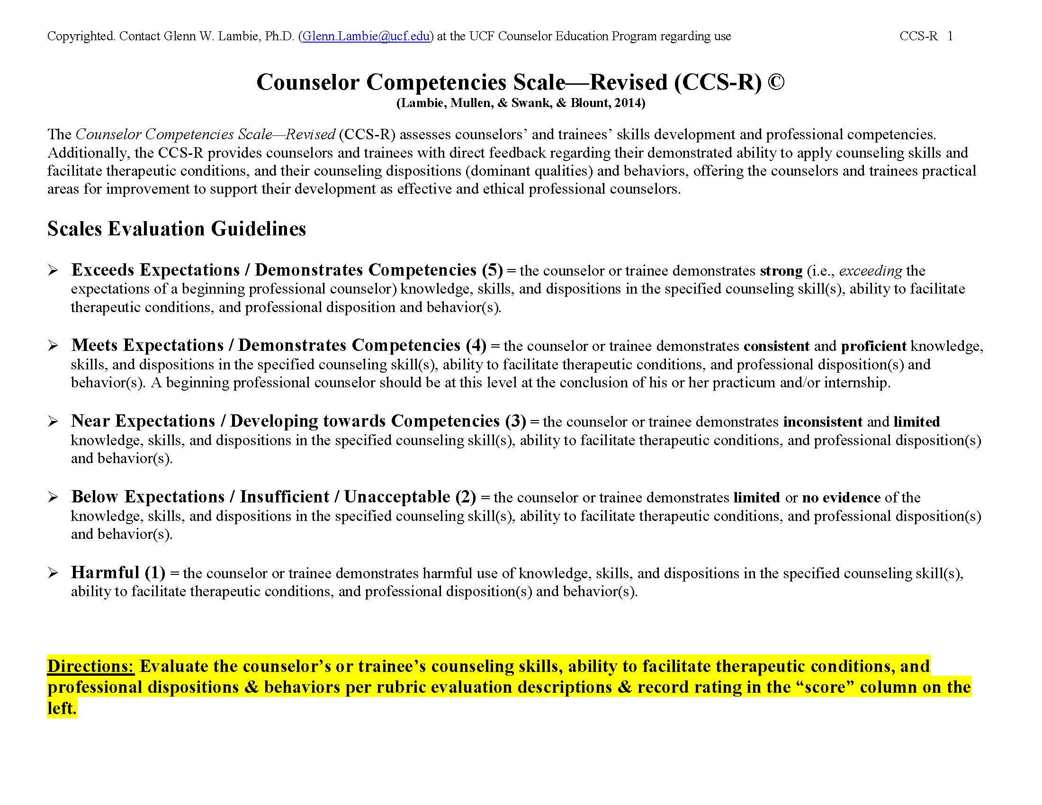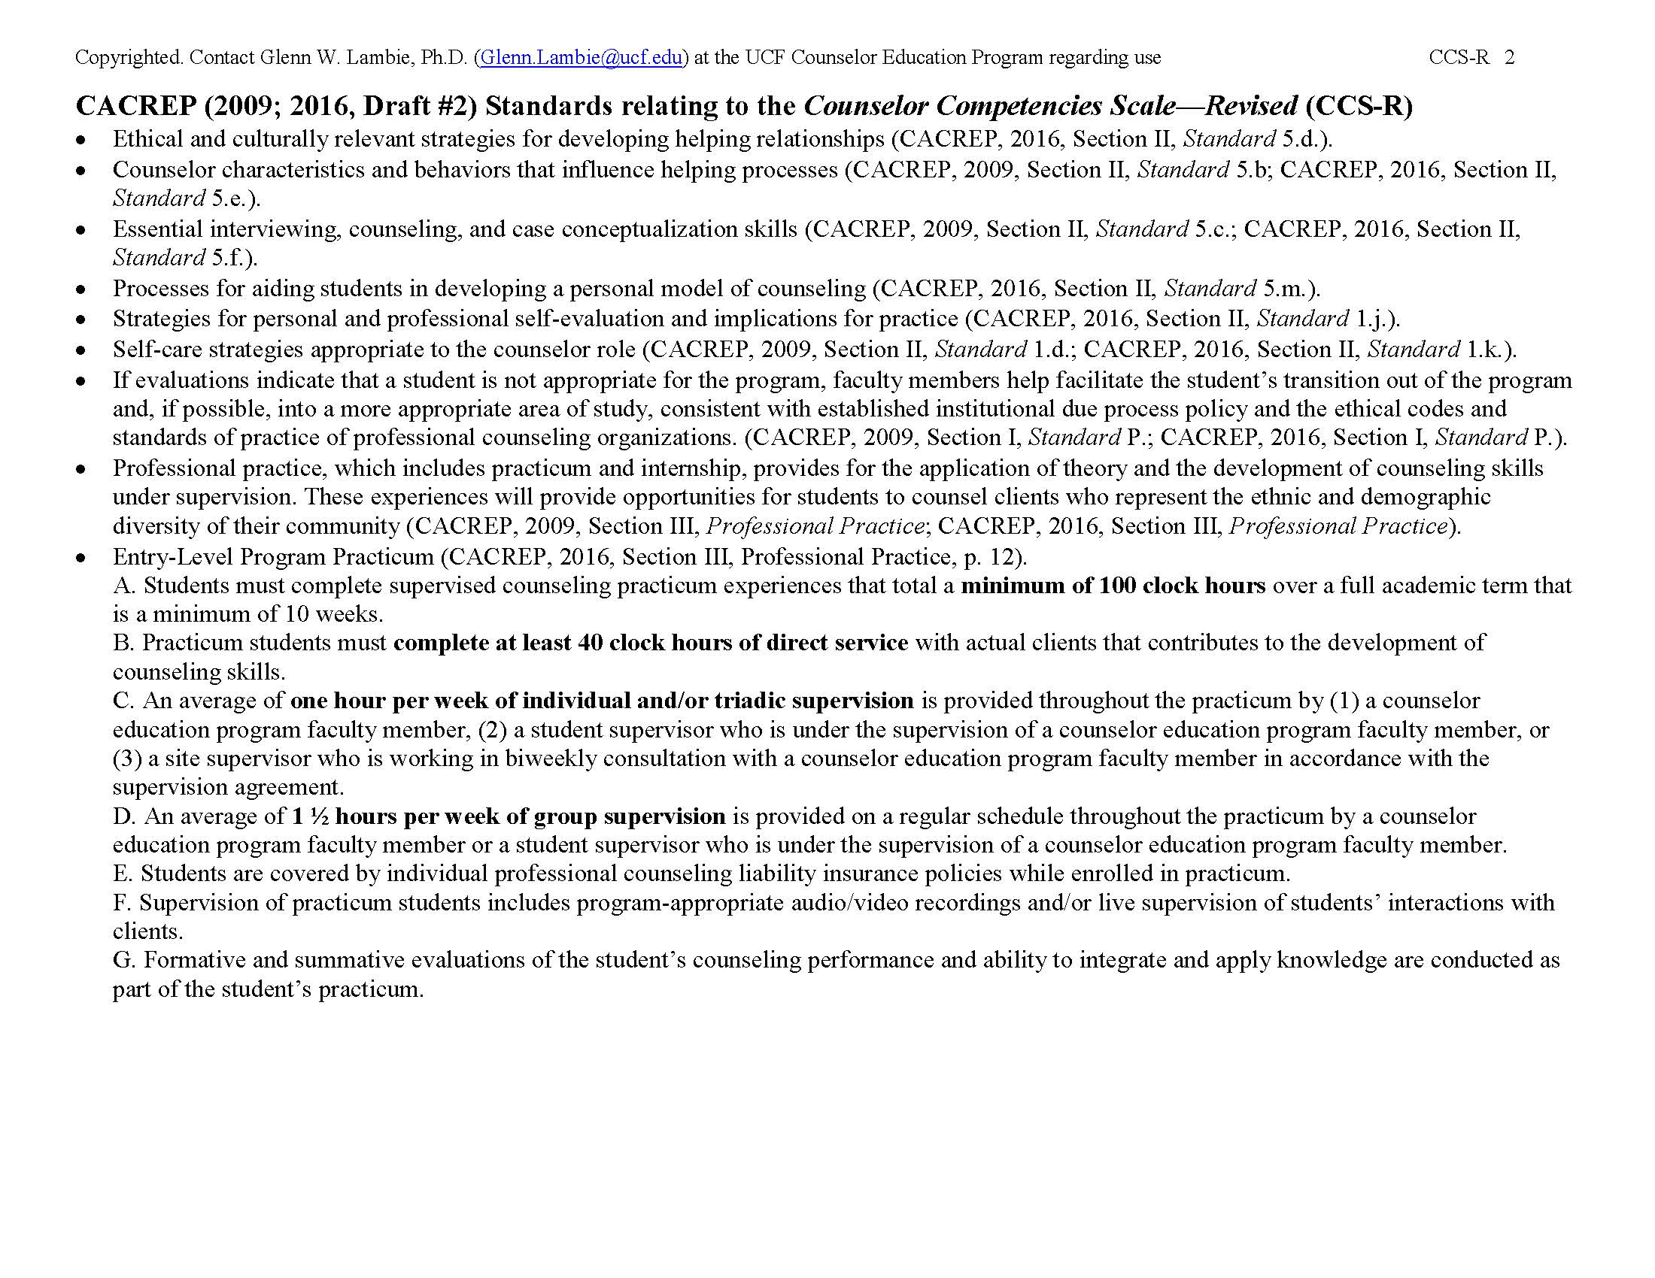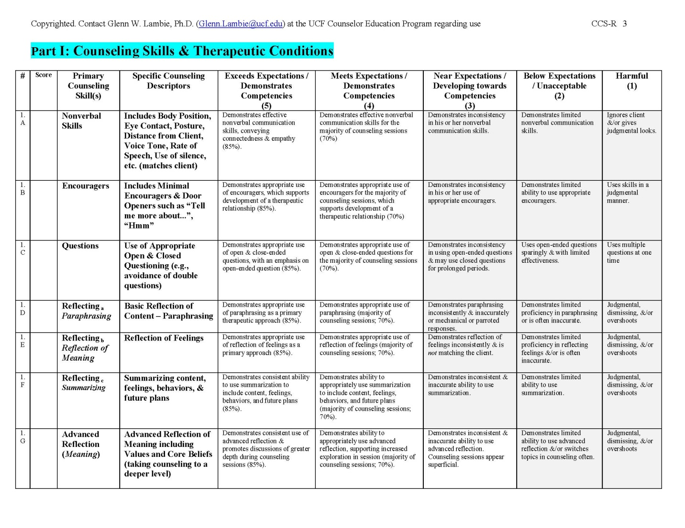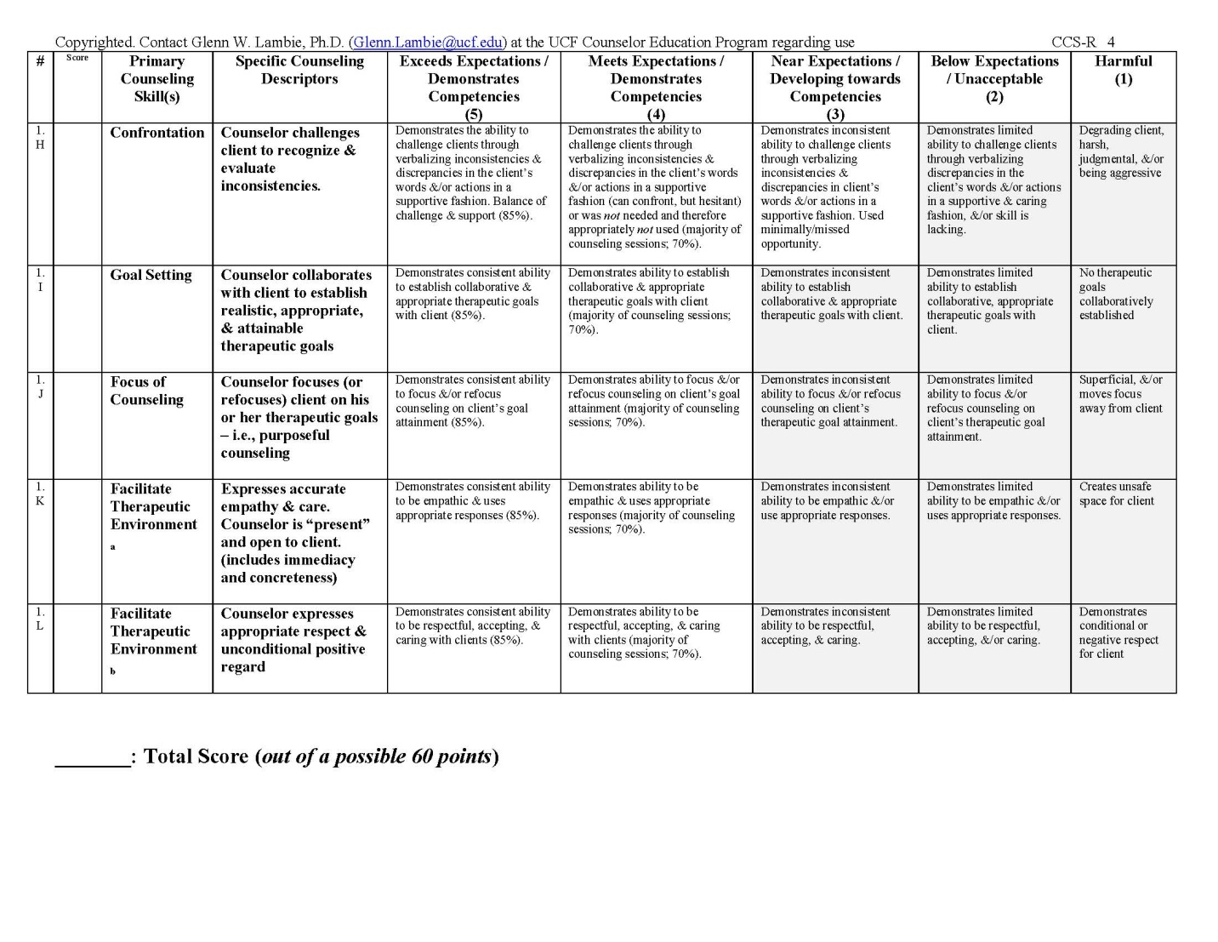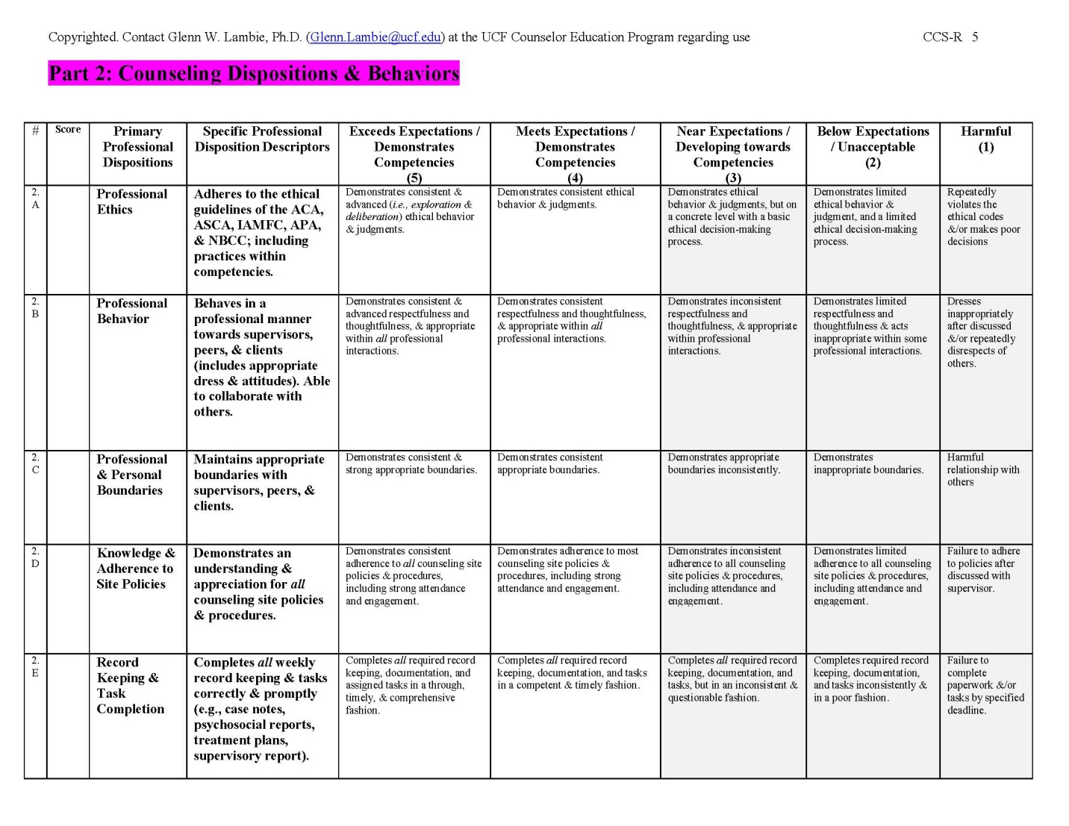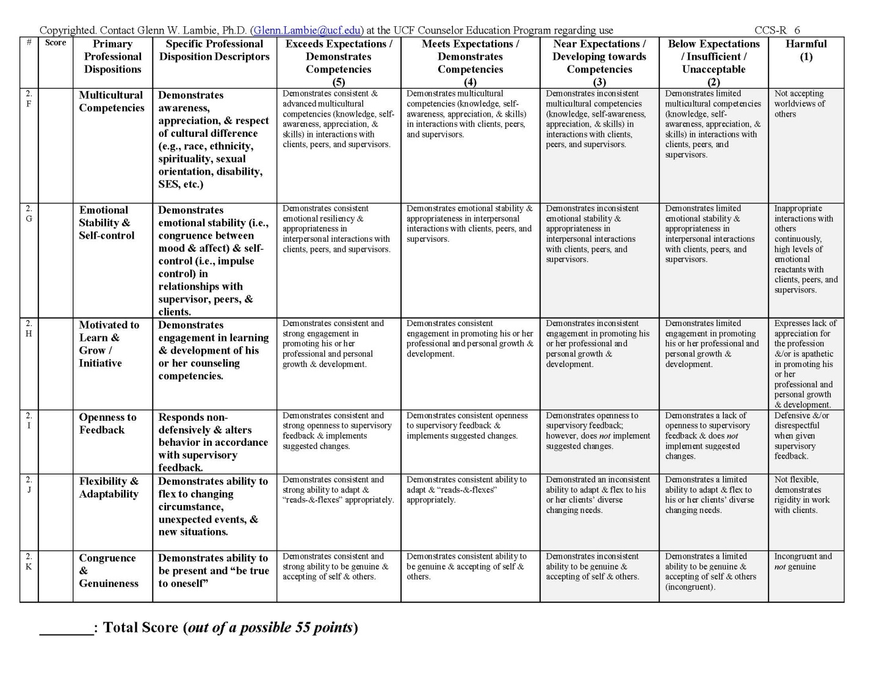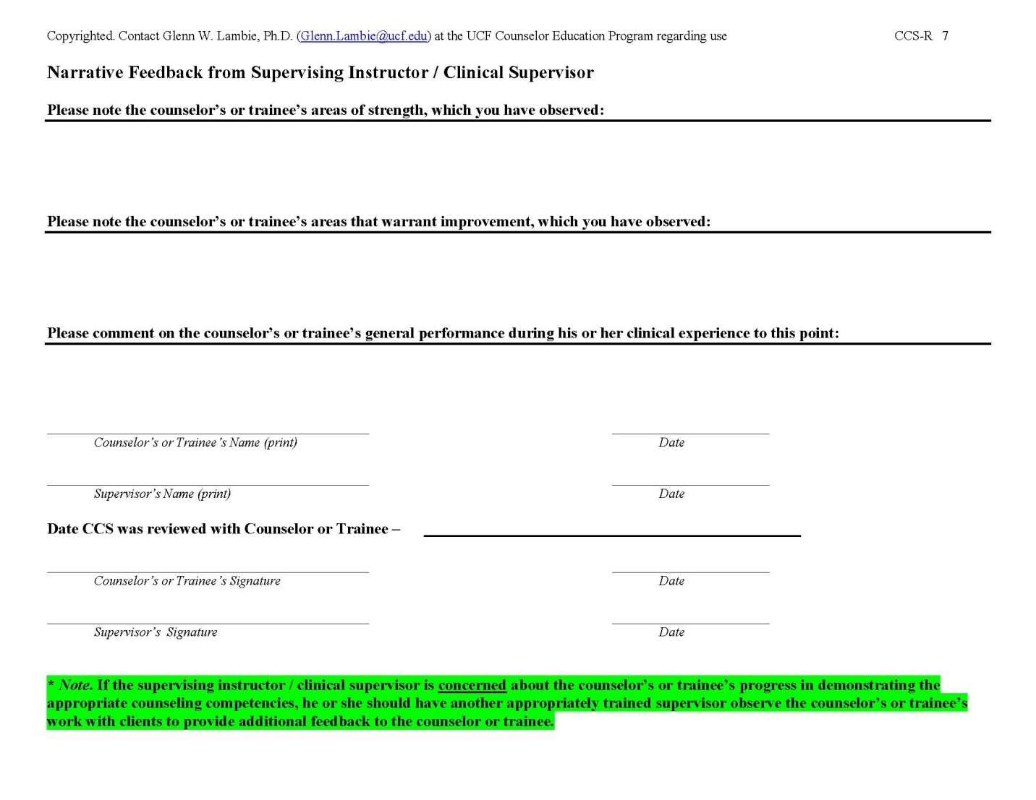

Appendix D: Forms to Complete Before Internship 1 & 2 (CG 598A & B)

School Counseling Program Practicum/Internship Student and Site Information Form
Notification of finding a site must be submitted by MAY 1 for a practicum starting during Fall semester and no later than DECEMBER 1 for a practicum starting during Spring semester. These deadlines are non-negotiable. Use the online School Counseling Program Practicum/Internship Student and Site Information Form to submit this information. A confirmation email of your submission will be sent to you. Keep a copy of this email in your electronic portfolio.

Important to note: You must fill out this form even if you are staying at the same site from the previous semester. Failure to submit this by the deadlines indicated above may result in a student being unable to enter the course.

Participatory Agreement
John Carroll University
School Counseling Program
PAGE 1 OF 5

CG 591- Practicum or CG 598A/B – School Counseling Internship

Dear Principal,

The school counseling graduate student, ____________________________________________, is nearing the end of a long, rigorous course of study leading to licensure as a school counselor. While John Carroll University believes it has provided required coursework in theory, ethical and legal guidelines for practice, and basic counseling skills and techniques, practical experience is still the best method of learning to become a good school counselor. The student is asking that you consider making your site available for attaining the required number of contact hours of counseling experience with the children and adolescents in your school.

If our student is already employed at your site in a teaching role, we realize valuable release time for the student to meet their obligations for this experience may be required. Further, we appreciate the time you and your staff set aside for a non-employee student. All prospective practicum and/or internship students will have the required background checks and personal liability insurance plans before beginning at your site. We sincerely appreciate your willingness to make this opportunity available to one of our graduate students. We believe the careful, supervised work of our counselor trainees will be a real asset to your school in terms of service to children and the broader school community.

John Carroll University expects the highest of ethical practice from all of its counselor practicum/internship students and we further recognize your right to terminate from practicum or internship any individual who has, upon joint review, been judged to have violated school policy or has otherwise acted in an unprofessional or unethical manner while representing John Carroll on-site. It shall be further understood that no practicum or internship student will expect additional remuneration, compensation, or special consideration for future employment at your site in exchange for their service as a counselor intern.

I welcome and thank you for your joint participation with John Carroll University in providing this opportunity for our student.

Nathan C. Gehlert, Ph.D.
Chair and Associate Professor,
Department of Counseling
Director, Integrated Behavior Health Specialization (216) 397-4697

Participatory Agreement
John Carroll University
School Counseling Program
PAGE 2 OF 5

Part One:
Internship Practicum
Student Name: _______________________________________________________________
Address: ______________________________________________________________________
Work Phone: _______________________Best Time to Call: ______________________
Home Phone: ______________________ Best Time to Call: ______________________
Are you employed at the practicum/internship site? Yes_____ No_____
If yes, how long have you been employed on-site? _______Years
If yes, what are your current duties; subjects taught; grade level(s)?
_________________________________________________________________________________
_________________________________________________________________________________
Part Two:
Practicum/Internship Site School: __________________________________________
Site School’s Address: ________________________________________________________
__________________________________________________________________________________
Site School’s Phone Number: ________________________________________________
Grade Levels Served: _________________________________________________________
Site School’s Principal: _______________________________________________________
Intern’s Supervisory Counselor: _____________________________________________
Site Supervisor’s Phone Number: ____________________________________________
Site Supervisor’s Email: _______________________________________________________

The John Carroll University school counselor practicum/internship student identified in Part One above, is required to complete ____ semesters of practicum / internship (choose one) to complete requirements for State of Ohio licensure as a school counselor. The practicum/internship student is expected to document _______ total hours of practicum/internship experience, including ______ hours of direct service contact with K-12 students present at the site chosen for practicum/internship. Some examples of direct service contact hours are: individual counseling with children; group counseling with children; service as an I.E.P. or 504 team member; direct consultation to a parent of a child. All practicum and internship students are required to be supervised by a licensed school counselor on-site as well as a licensed or certificated University supervisor off-site. All interns are required to purchase professional counseling liability insurance prior to entering practicum or internship. All practicum and internship students are required to meet with their
Participatory Agreement
John Carroll University
School Counseling Program
PAGE 3 OF 5

on-site supervisor a minimum of one hour for every 20 hours of internship experience, or more frequently if the on-site supervisor requests. All interns are required to attend either CG 591 (School Counseling Practicum) or CG 598A/B (School Counseling Internship) class at John Carroll University as part of their off-site supervision. It is desirable to audio or video record intern sessions with children for effective supervision. If the site school, its principal, and supervising counselor jointly determine that audio or video recording of session(s) may occur, a proper consent to record form shall be secured and signed by students and/or parents/guardians prior to any taping. John Carroll University will provide such a form if this is needed. The responsibilities of the school counselor intern, the school site, and the University are clearly delineated and are as follows:

John Carroll University agrees:

1. To select a student who has successfully completed all the prerequisite courses.

2. To assign a University faculty liaison to facilitate communication between the University and the practicum/internship experience site.

3. That the faculty liaison shall be available for consultation with both site supervisors and students.

4. That the Practicum Instructor or Internship Instructor will provide class/group supervision sessions the student is required to attend with the purpose of helping students further clarify their work with clients and to assist them in being prepared for clinical supervision. The Instructor is responsible for the assignment of a final grade.

5. To require that students have adequate liability insurance.

The Practicum/Internship Site agrees:

1. To assign a designated Site Supervisor who is licensed school counselor with at least two years of school counseling experience, who has a demonstrated interest in training, and who is willing to provide 1 hour of student supervision for every 20 hours of student internship experience.

2. To provide the student with an overall orientation to the school’s specific services necessary for the effective implementation of the practicum/internship experiences.

3. To provide opportunities for the student to engage in a wide variety of professional activities, over and above the required direct service hours.

Participatory Agreement
John Carroll University
School Counseling Program
PAGE 4 OF 5

4. To allow the student the potential/possibility to audio or video record counseling sessions (with student and/or parental/guardian consent) for supervisory purposes.

5. To encourage students to gain experience in the use of a variety of professional resources such as assessment instruments, relevant computer software, print and non-print media, professional literature, research findings, and appropriate referral sources and providers.

6. To evaluate the student's performance at the conclusion of their practicum and internship, based upon criteria established by the School Counseling Program at John Carroll University, and to evaluate the John Carroll University Counseling Program on the form provided.

The Practicum Student/Intern agrees:

1. To abide by existing policies and procedures of the given school and local education agency.

2. To prepare a proposed plan for the practicum/internship experience, which includes individual goals and activities designed to facilitate the achievement of these goals. This plan should be endorsed by the Site Supervisor.

3. To perform functions agreed upon in the proposed plan, as well as additional functions as directed by the Site Supervisor.

4. To inform the Site Supervisor of problems or situations which might affect or change the student's ability to function within the school setting.

5. To keep a daily log of overall hours, direct contact hours, and supervision hours, in accordance with John Carroll University guidelines.

6. To secure and provide evidence of appropriate, personally held liability insurance prior to starting practicum/internship.

7. To demonstrate behavior in accordance with the American School Counselor Association’s Ethical Standards for School Counselors, adhering closely to standards regarding the maintaining of student confidentiality.

8. To obtain written consent regarding audio or video recording from the necessary parties (students and/or parents/guardians) prior to treatment.

Participatory Agreement
John Carroll University
School Counseling Program
PAGE 5 OF 5

It is mutually agreed that:

1. Any problems or grievances that occur with students will be handled in cooperation with the school, John Carroll University Instructor and/or School Counseling Program Coordinator, and the Practicum Student or Intern.

2. If any involved party deems it necessary to cancel this agreement, notification must be given at least three weeks prior to the intended date of termination.

Participatory Agreement
This agreement is to promote clarity of understanding between the practicum/internship student identified in Part One, the site principal, the counselor supervisor, and John Carroll University’s School Counseling Practicum/Internship Coordinator. It is not a binding, legal contractual agreement.
I, ___________________________________________________ (Site School Principal), have reviewed this Participatory Agreement and offer my school’s counselor for supervision of the practicum/internship student identified in Part One above. I agree that the intern may devote the required time in direct contact services with children for the duration of the internship period, in return for services as a school-counselor-in-training.

ALL PARTIES: PLEASE SIGN AND DATE THIS AGREEMENT

Practicum/Internship Student: _____________________________________________ Date:________________
Site School Principal: _________________________________________________________ Date:________________
Site Supervisor: _______________________________________________________________ Date:________________
JCU Coordinator: ______________________________________________________________ Date:________________

Assignment of Supervisor Form
John Carroll University
School Counseling Program

Directions: This form must be completed along with the Participatory Agreement Form and the original submitted to the JCU School Counseling Practicum/Internship Coordinator.

School Counseling Practicum/Internship Student: ________________________________________________
School/Site Name: ____________________________________________________________________________________
Assigned Supervisor Name: __________________________________________________________________________

For Practicum

Practicum will extend for ________ hours a week for _______ weeks, totaling at least 100 clock hours of service, of which a minimum of 40 hours are devoted to direct service such as individual counseling, group counseling, group guidance, working with parents/guardians, or serving on teams (e.g., IEP or 504 meetings). One hour of supervision is to be provided weekly.

For Internship

Internship will extend for _______ hours a week for _______ weeks, totaling at least 600 clock hours of service, of which a minimum of 240 clock hours are devoted to direct service such as individual counseling, group counseling, group guidance, working with parents/guardians, or serving on teams (e.g., IEP or 504 meetings). One hour of supervision is required for every 20 hours of internship experience. The field/school supervisor will assume full and direct legal responsibility for all students.

Site Supervisor Signature: ________________________________________________________ Date: ______________
Printed Site Supervisor Name: ___________________________________________________ Date: ______________
Practicum/Internship Student Signature: _______________________________________ Date: ______________
Practicum/Internship Student Name: ___________________________________________ Date: ______________

Site Supervisor Qualifications Form
John Carroll University
School Counseling Program

SUPERVISOR SCHOOL AND CONTACT INFORMATION

__________________________________________________________________________________
Name of Practicum/Internship Supervisor Name of School

___________
Current Job Title

___________
School Address

( ) ___________
E-mail Address Work Telephone Number

SUPERVISOR EDUCATIONAL/ACADEMIC INFORMATION

___________
Highest Degree Earned Graduate University Attended

___________
Year Graduated Years of experience Years supervising

SUPERVISOR LICENSURE INFORMATION

___________
Type of License State & Department License #ID &
Issuing License Expiration Date

___________
Type of License State & Department License #ID
Issuing License Expiration Date

SUPERVISOR CERTIFICATION INFORMATION (if applicable)

______________________________________________________________________________________________________________________________
Type of Certification State & Department or Certification ID # &
Organization Issuing Certificate Expiration Date

Appendix E: Forms to Complete During Internship 1 & 2 (CG 598A & B)

Practicum/Internship Log
Link to electronic Practicum/Internship Log here.

Practicum/Internship Log
John Carroll University
Counseling Program
Student: _________________________________________________ Site: ______________________________________________________
JCU Supervisor: _________________________________________ Site Supervisor: _________________________________________
Semester: ________________________________________________ Practicum or Internship (A/B): _______________________

Date: | Total Hours: | Individual Counseling: Hours: | Group Hours: | Other Hours: | On-Site Supervision Hours: | Class Supervision Hours:
Totals:

Site Supervisor: _______________________________________________________________ Date: ____________________________

School Counseling Practicum/Internship Plan of Action
John Carroll University, School Counseling Program

To be completed at the beginning of each semester of practicum and internship

Student Name: _________________________________________ Date: __________________

Objective | How | Anticipated Time Frame | Date Objective Met
Develop this plan |  | Should be completed prior to beginning practicum/internship
M. Ed.
Discuss evidence-based interventions to be used during semester
Individual counseling
Co-lead/lead group counseling
Plan and conduct classroom guidance activities
Consultation with parents/teachers
Attend staff meetings
Six additional objectives
1.
2.
3.
4.
5.
6.

________________________________________________________ ______________________
Supervisor Signature Date

Weekly Intern Activity Report & Log
John Carroll University
School Counseling Program
Directions: This is an optional form that shows you how you may track the hours at your site. Should you decide to use this, this form should be completed weekly and saved in your electronic portfolio to be shared with your instructor.

Name of Student: _____________________________ Date: __/__/__ - __/__/__ Week #: _____
Name of School: ______________________________ Site Supervisor: _______________________
Activity | Mon | Tues | Wed | Thurs | Fri | Current Week Total | Previous Total | Cumulative Total
Supervision
- Individual
- Group
Counseling
- Individual
- Group
Consultation
- Parent
- Administrator
- Teacher
- Other:
Staff Meetings
In-Service Training
Documentation
Other:
Total:

Session Recording Form: Student
John Carroll University
School Counseling Program

K-12 Student Name: __________________________________________________________________________
K-12 Student Address: ________________________________________________________________________
________________________________________________________________________
K-12 Student Home Phone: ____________________________________

I agree to have my counseling session audio or video recorded for purposes of supervision for a practicum/internship student from the School Counseling Program at John Carroll University. I understand that this practicum/internship student has completed advanced course work in the field of counseling and will be supervised by ____________________________________________________, a John Carroll University Practicum Supervisor or Site Supervisor. Recorded information is used only for training, with all recordings erased at the completion of my involvement in counseling or the practicum/internship student’s course requirements. Information gathered in the counseling interview is strictly confidential and privileged in accordance with the American School Counselor Association Ethical Standards for School Counselors. Exceptions to this confidentiality occur when there is suspected child abuse or an indication of imminent danger to oneself or others.

If for any reason questions arise regarding the counseling arrangement or session recording agreement, or if I am dissatisfied for any reason, I have every right to meet with the practicum/internship student and/or their site supervisor named above.

I have read the above and understand the nature of the supervisory procedures. Any related questions have been answered to my satisfaction.

_______________________________________________________________________________________________________
Signature of K-12 Student Date

_______________________________________________________________________________________________________
Signature of Practicum/Internship Student Date

Session Recording Form: Parent/Guardian
John Carroll University
School Counseling Program

K-12 Student Name: __________________________________________________________________________
Parent/Guardian Name: _____________________________________________________________________
Parent/Guardian Address: ___________________________________________________________________
___________________________________________________________________
Parent/Guardian Phone (please provide at least one):
(home) ___________________________ (cell) ____________________________ (office) _________________________

I agree to have my child’s counseling session audio or video recorded for purposes of supervision for a practicum/internship student from the School Counseling Program at John Carroll University. I understand that this practicum/internship student has completed advanced course work in the field of counseling and will be supervised by ____________________________________________________, a John Carroll University Practicum Supervisor or Site Supervisor. Recorded information is used only for training, with all recordings erased at the completion of my child’s involvement in counseling or the practicum/internship student’s course requirements. Information gathered in the counseling interview is strictly confidential and privileged in accordance with the American School Counselor Association Ethical Standards for School Counselors. Exceptions to this confidentiality occur when there is suspected child abuse or an indication of imminent danger to oneself or others.

If for any reason questions arise regarding the counseling arrangement or session recording agreement, or if I or my child are dissatisfied for any reason, I have every right to meet with the practicum/internship student and/or their site supervisor named above.

I have read the above and understand the nature of the supervisory procedures. Any related questions have been answered to my satisfaction.

____________________________________________________________________________________________________
Signature of Parent/Guardian Date

____________________________________________________________________________________________________
Signature of Practicum/Internship Student Date

Session Review Form
John Carroll University, School Counseling Program
PAGE 1 OF 3

Student Name: ________________________________________________ Date of Session: ___________________________
Supervisor's Name: _________________________________________ Date of Session Review: __________________
Type of session: ____ Individual ____ Group _____ Classroom Guidance Lesson Session #: ______
For Supervisor: Please rate the student on the below criteria regarding their use of counseling skills when working with students in an individual session, group session, or classroom guidance lesson. Please provide practicum student interns the opportunity to practice their skills in sessions prior to observing and filling out the first Session Review Form.

Please rate each of the following categories: | Exceeds Expectations | Meets Expectations | Does Not Meet Expectations
Counseling Techniques
Open-ended questions | 10 | 9 | 8
Paraphrasing (content) | 10 | 9 | 8
Reflections (thoughts/feelings) | 10 | 9 | 8
Summarizations | 10 | 9 | 8
Basic Counseling Skills
Warmth, respect, positive regard, and genuineness | 10 | 9 | 8
Attending skills utilized | 10 | 9 | 8
Connecting/Linking content, thoughts, or feelings  from previous session(s) | 10 | 9 | 8
Use of evidence-based interventions | 10 | 9 | 8
Refrains from lecturing and/or giving advice | 10 | 9 | 8
Displays empathy | 10 | 9 | 8
Silence used effectively | 10 | 9 | 8
Use of Self
Congruent body language (eye contact, posture, etc.) | 10 | 9 | 8
Congruent voice, tone, and pace | 10 | 9 | 8
Professional demeanor and presentation | 10 | 9 | 8
Planning and Structure of Session
Evidence of planning for session/lesson | 10 | 9 | 8
Opening of session/lesson well implemented | 10 | 9 | 8
Focus was session/lesson was clear | 10 | 9 | 8
Closing was on time and natural | 10 | 9 | 8
Multicultural Competency
Open to gaining cultural knowledge | 10 | 9 | 8
Respectful of personal values & beliefs of student(s) | 10 | 9 | 8

Total Points: _________ / 200
Session Review Form
John Carroll University, School Counseling Program
PAGE 2 OF 3

For Supervisor to fill out:

Intern strengths observed: ____________________________________________________________________________________
___________________________________________________________________________________________________________________
___________________________________________________________________________________________________________________
___________________________________________________________________________________________________________________
___________________________________________________________________________________________________________________
___________________________________________________________________________________________________________________
___________________________________________________________________________________________________________________
___________________________________________________________________________________________________________________

Types of evidence-based interventions used: _______________________________________________________________
_________________________________________________________________________________________________________________________________________________________________________________________________________________________________________________________________________________________________________________________________________________________
___________________________________________________________________________________________________________________
___________________________________________________________________________________________________________________

Skills present/missing for type of session (individual, group, or guidance lesson):
___________________________________________________________________________________________________________________
___________________________________________________________________________________________________________________
___________________________________________________________________________________________________________________
___________________________________________________________________________________________________________________
___________________________________________________________________________________________________________________
___________________________________________________________________________________________________________________

Areas and suggestions for improvement: ____________________________________________________________________
___________________________________________________________________________________________________________________
___________________________________________________________________________________________________________________
___________________________________________________________________________________________________________________
___________________________________________________________________________________________________________________
___________________________________________________________________________________________________________________
___________________________________________________________________________________________________________________

Session Review Form
John Carroll University, School Counseling Program
PAGE 3 OF 3

For Student: After reviewing the feedback from your supervisor, fill out the following.

Your strengths from session: _________________________________________________________________________________
___________________________________________________________________________________________________________________
___________________________________________________________________________________________________________________
___________________________________________________________________________________________________________________
___________________________________________________________________________________________________________________
___________________________________________________________________________________________________________________
___________________________________________________________________________________________________________________

Areas for improvement: _______________________________________________________________________________________
___________________________________________________________________________________________________________________
___________________________________________________________________________________________________________________
___________________________________________________________________________________________________________________
___________________________________________________________________________________________________________________
___________________________________________________________________________________________________________________

Feedback requested and discussed with supervisor: _______________________________________________________
_________________________________________________________________________________________________________________________________________________________________________________________________________________________________________________________________________________________________________________________________________________________
___________________________________________________________________________________________________________________
___________________________________________________________________________________________________________________

Plans/goals for future sessions (to be made in collaboration with supervisor): ___________________________________________________________________________________________________________________
______________________________________________________________________________________________________________________________________________________________________________________________________________________________________
___________________________________________________________________________________________________________________
___________________________________________________________________________________________________________________
___________________________________________________________________________________________________________________

Supervisor's Signature ________________________________________________ Date __________________________________

Student's Signature ____________________________________________________ Date __________________________________

Client Satisfaction Survey
John Carroll University
School Counseling Program
Name of Counselor ___________________________________

Semester/year _____________________________

Number of counseling sessions you have participated in with this counselor ______

Indicate the extent to which you AGREE or DISAGREE with each of the statements below.

Strongly disagree (1) Disagree (2) Neither agree or disagree (3) Agree(4) Strongly Agree (5)

1. I would rate my overall counseling experience positively _____

2. The counseling services I am receiving meet my needs _____

3. My counselor is interested in and accepting of me _____

How much have you benefited so far from being in counseling?
Check one
_____ I’ve gotten much worse
_____ I’ve gotten worse
_____ I’m about the same
_____ I’m better
_____ I’m much better

Please rate the overall level of distress that brought you to counseling
High 5____ 4____ 3____ 2____ 1____ low

Please rate the overall level of that same distress now
High 5____ 4____ 3____ 2____ 1____ low

Please rate the overall service provided by my counselor
High 5____ 4____ 3____ 2____ 1____ low

Appendix G: Forms to Complete by the End of Internship 2 (CG 598B)

Program Evaluation Form
John Carroll University
School Counseling Program

The Program Evaluation is automatically emailed via the Survey Monkey system at the end of the semester to CG 598B students and their site supervisors for completion.

Professional Performance Fitness Evaluation
John Carroll University Counseling Program
PAGE 1 OF 3

Student: ______________________________________________ Semester/Year: __________________________
Site Name: ___________________________________________

Evaluation completed by (check and write name):
____ Self-Assessment
____ JCU Practicum/Site Supervisor Name: _______________________________________________
____ JCU Instructor Name: _______________________________________________
N - No opportunity to observe
1 - Does not meet criteria for program level
2 - Meets criteria only minimally or inconsistently for program level
3 - Meets criteria consistently at this program level

Therapeutic Skills and Abilities
- The student demonstrates the ability to establish a therapeutic relationship. | N | 1 | 2 | 3
- The student demonstrates therapeutic communication skills including
- Creating appropriate structure: (setting and maintaining the boundaries of the therapeutic relationship throughout the work (i.e. setting parameters for meeting time and place, maintaining time limits, etc.) | N | 1 | 2 | 3
- Understanding content: (understanding the primary elements of the client’s story.) | N | 1 | 2 | 3
- Understanding context: (understanding the uniqueness of the story elements and their underlying meaning.) | N | 1 | 2 | 3
- Responding to feelings: (identifying client affect and addressing those feelings in a therapeutic manner.) | N | 1 | 2 | 3
- Congruence-genuineness: (demonstrating external behavior consistent with internal affect.) | N | 1 | 2 | 3
- Establishing and communicating empathy: (taking the perspective of the client without over-identification with client’s experience.) | N | 1 | 2 | 3
- Non-verbal communication: (demonstrating effective use of head, eye, hands, feet, posture, voice, attire, etc.) | N | 1 | 2 | 3
- Immediacy: (staying in the here and now) | N | 1 | 2 | 3
Professional Performance Fitness Evaluation
John Carroll University Counseling Program
PAGE 2 OF 3

- Timing: (responding at the optimal moment) | N | 1 | 2 | 3
- Intentionally: (responding with a clear understanding of one’s own therapeutic intention.) | N | 1 | 2 | 3
- Self-disclosure: (skillful and carefully considered for a specific purpose.) | N | 1 | 2 | 3
- The student demonstrates awareness of power differences in the therapeutic relationship and manages these differences therapeutically. | N | 1 | 2 | 3
- The student collaborates with the client to establish clear therapeutic goals. | N | 1 | 2 | 3
- The student facilitates movement toward the client goals. | N | 1 | 2 | 3
- The student demonstrates adequate knowledge of a wide variety of theoretical bases. | N | 1 | 2 | 3
- The student demonstrates the capacity to match appropriate interventions to the presenting clinical profile in a theoretically consistent manner. | N | 1 | 2 | 3
- The student creates a safe clinical environment. | N | 1 | 2 | 3
- The student demonstrates willingness and ability to articulate analysis and resolution of ethical dilemmas. | N | 1 | 2 | 3
Professional Responsibility
- The student conducts self in an ethical manner to promote confidence in the counseling profession and agency. | N | 1 | 2 | 3
- The student relates to professors, colleagues, supervisors and others in a manner consistent with stated agency standards. | N | 1 | 2 | 3
- The student demonstrates application of legal requirements relevant to counseling training practice and agency. | N | 1 | 2 | 3
Competence
- The student recognizes the boundaries of their particular competencies and the limitations of their expertise. | N | 1 | 2 | 3
- The student demonstrates knowledge and respect for agency policies and procedures. | N | 1 | 2 | 3
- The student seeks appropriate supervision when providing services outside of competency. | N | 1 | 2 | 3

Professional Performance Fitness Evaluation
John Carroll University Counseling Program
PAGE 3 OF 3
Maturity
- The student demonstrates appropriate self-control (such as anger control, impulse control) in interpersonal relationship with supervisors, colleagues and clients. | N | 1 | 2 | 3
- The student is honest, fair, and respectful of others. | N | 1 | 2 | 3
- The student is aware of their own belief systems, values, needs, and limitations and the effect of these on their work. | N | 1 | 2 | 3
- The student demonstrates ability to receive, integrate and utilize feedback from colleagues and supervisors. | N | 1 | 2 | 3
- The student exhibits appropriate levels of self-assurance, confidence, and trust in own ability. | N | 1 | 2 | 3
- The student follows professionally recognized problem solving process, seeking to informally solve problems first with the individual(s) with whom the problem exists. | N | 1 | 2 | 3
Integrity
- The student refrains from making statements that are false, misleading or deceptive. | N | 1 | 2 | 3
- The student avoids improper and potentially harmful dual relationships. | N | 1 | 2 | 3
- The student respects the rights of individual to privacy, confidentiality, and choices regarding self-determination and autonomy. | N | 1 | 2 | 3
Cultural Competence
- The student respects the fundamental rights, dignity and worth of all people. | N | 1 | 2 | 3
- The student respects cultural, individual, and role differences, including those due to age, sex, race, ethnicity, national origin, religion, sexual orientation, gender identity, ability, language, and socioeconomic status. | N | 1 | 2 | 3
- The student understands personal cultural lens and potential biases. | N | 1 | 2 | 3
- The student has or seeks out knowledge of cultural groups. | N | 1 | 2 | 3
- The student demonstrates culturally competent therapeutic skills and case conceptualizations. | N | 1 | 2 | 3
Comments/Suggestions:

Counseling Practicum/Internship Assessment of Clinical/School Experience
John Carroll University
PAGE 1 OF 3

Student Name:____________________________________________________________________________________
Course: _______________________________________ Semester/Year: ___________________________
Agency/School Name: ___________________________________________________________________________
Name of Site Supervisor: ________________________________________________________________________
Total Number of Hours Accrued at Site: _____________

This evaluation is for the purpose of providing feedback to the University regarding student perceptions of the practicum/internship experience. This instrument is designed as a guide to facilitate the sharing of the most significant perceptions and impressions that occur throughout the practicum/internship experience. As a student counselor and a beginning professional, you are urged to complete this instrument completely and honestly. You should already have begun this kind of critical sharing with your site/clinical supervisor, others in the agency/school, and your instructor. Your responses can aid your own professional development, and your assessment will significantly help the University be even more responsive to student needs.
**This information WILL NOT be viewed by site supervisors/employees

1. Complete the rating form as follows (circle appropriate responses for each item):
5 --- Indicates complete satisfaction or an extremely positive response with the item.
Where behavior is referred to, the behavior was always present when appropriate.
4 --- Moderate satisfaction: Desired behavior or condition was frequently present.
3 --- Somewhat satisfied: Desired behavior or condition was sometimes absent.
2 --- Somewhat dissatisfied: Desired behavior or condition was often absent.
1 --- Extremely dissatisfied: Desired behavior or condition was seldom present.
X --- It is not possible to assess this item.

2. Provide comments regarding those items for which you have a special concern.

I. The Practicum/Internship Process

1 | Was there sufficient information about the practicum/internship prior to actually starting the experience? | 5 | 4 | 3 | 2 | 1 | X
2 | Did you feel the kind of setting provided was appropriate to your needs and interests? | 5 | 4 | 3 | 2 | 1 | X
3 | Was orientation at the agency/school sufficient when the experience began? | 5 | 4 | 3 | 2 | 1 | X
4 | Overall, did the site supervisor meet responsibilities for your practicum/internship experience? | 5 | 4 | 3 | 2 | 1 | X
5 | During the experience, did you feel that you were treated as an individual with respect for your own special circumstances? | 5 | 4 | 3 | 2 | 1 | X
6 | Was the agency/school adequately prepared for your arrival? | 5 | 4 | 3 | 2 | 1 | X

Counseling Practicum/Internship Assessment of Clinical/School Experience
John Carroll University
PAGE 2 OF 3

II. The Agency/School Setting

1 | Was the interaction with other counselors and related disciplines sufficient? | 5 | 4 | 3 | 2 | 1 | X
2 | Did the agency/school provide you with adequate working conditions? | 5 | 4 | 3 | 2 | 1 | X
3 | Overall, did you feel the agency/school attached sufficient importance to your experience? | 5 | 4 | 3 | 2 | 1 | X

III. Professional Development

1 | Did the experience acquaint you with the operation of a community service agency/school? | 5 | 4 | 3 | 2 | 1 | X
2 | Did the experience improve your capacity to work with people in a helping relationship? | 5 | 4 | 3 | 2 | 1 | X
3 | Did the placement acquaint you with resources available in the community? | 5 | 4 | 3 | 2 | 1 | X
4 | Did the experience significantly increase your knowledge of specific problems in the community, e.g., poverty, mental illness, aging, alcoholism and other addictions, and so on? | 5 | 4 | 3 | 2 | 1 | X
5 | Rate your general level of satisfaction with the amount and kind of activities you were assigned. | 5 | 4 | 3 | 2 | 1 | X
6 | Was there a sufficient diversity of learning activities? | 5 | 4 | 3 | 2 | 1 | X
7 | Were there opportunities to be part of the “larger agency/school” such as by attending staff meetings, in-service training, and so on? | 5 | 4 | 3 | 2 | 1 | X
8 | Did this agency/school experience help you understand and use professional record keeping procedures? | 5 | 4 | 3 | 2 | 1 | X

IV. Direct Supervision by Site Supervisor

1 | Did your supervisor stimulate professional counselor identity? | 5 | 4 | 3 | 2 | 1 | X
2 | Did your supervisor help you feel accepted and respected as a person? | 5 | 4 | 3 | 2 | 1 | X
3 | Did your supervisor help in demonstrating professional relationships with staff members at the site? | 5 | 4 | 3 | 2 | 1 | X
4 | Did your supervisor meet with you for supervision at established times and for the agreed upon time? | 5 | 4 | 3 | 2 | 1 | X
5 | Did your supervisor assist in conceptualizing your clients/students? | 5 | 4 | 3 | 2 | 1 | X
6 | Did your supervisor help clarify objectives for your counseling sessions? | 5 | 4 | 3 | 2 | 1 | X
7 | Did your supervisor help organize relevant case data in planning procedures for working with your clients/students? | 5 | 4 | 3 | 2 | 1 | X
8 | Did your supervisor guide you in generating your own solutions to problems faced with clients/students? | 5 | 4 | 3 | 2 | 1 | X
9 | Did your supervisor provide you with useful feedback regarding your counseling skills? | 5 | 4 | 3 | 2 | 1 | X

Counseling Practicum/Internship Assessment of Clinical/School Experience
John Carroll University
PAGE 3 OF 3

10 | Did your supervisor help you focus on how your personal style influenced clients/students? | 5 | 4 | 3 | 2 | 1 | X
11 | Did your supervisor adequately reinforce the development of your strengths and capabilities? | 5 | 4 | 3 | 2 | 1 | X
12 | Did your supervisor help you use appraisal instruments constructively in counseling? | 5 | 4 | 3 | 2 | 1 | X
13 | Was your supervisor helpful in critiquing your report writing? | 5 | 4 | 3 | 2 | 1 | X
14 | Did your supervisor allow and encourage you to evaluate your work with clients/students? | 5 | 4 | 3 | 2 | 1 | X
15 | Did your supervisor demonstrate cultural competency when working with you and other professionals/students? | 5 | 4 | 3 | 2 | 1 | X
16 | Did your supervisor demonstrate willingness to discuss cultural dynamics in clinical assessment, case conceptualization, and treatment? | 5 | 4 | 3 | 2 | 1 | X
17 | Would you recommend this site to other students? | 5 | 4 | 3 | 2 | 1 | X
18 | Would you recommend this supervisor to other students? | 5 | 4 | 3 | 2 | 1 | X

Please feel free to provide any additional thoughts about your site, supervisor, or experience here.

Would like to meet in person with the practicum/internship coordinator to discuss experience?

Yes ______ No _______

Please return this form to the Clinical Coordinator Assistant,
Amy Zucca, in AD309 or via email (azucca@jcu.edu)

